

**Community Paramedicine**

**Program Framework**

**Authors:**

K. Baqai BS, CCEMT-P

S. Chiang, EMT-P

D. Kugler, MD

J. Neitz, EMT, AEMD

E. Quellhorst BFA, NREMT-P, CCEMT-P, PNCCT, CMTE, EMD-Q

J. D. Washko, BS-EMSA, NREMT-P, AEMD

**Contributors:**

C. Borger, EMT-P

R. Jervis, MD

J. Jackson, EMT-P

D. Kaldor, EMT-P

E. Korneffel, EMT-P

T. Kwiatkowski MD, FACEP

P. Power, EMT-P

T. Robertson, EMT-P

J. Rofrano, EMT-P

A. Schwalberg, EMT-P

D. Shepherd, EMT-P

C. E. Smith, EMT-P

K. Smith, MD

G. Stark, EMT

**North Shore LIJ Health System –**

**Center for Emergency Medical Services** [**http://www.northshorelij.com/NSLIJ/CEMS**](http://www.northshorelij.com/NSLIJ/CEMS)

**15 Burke Lane**

**Syosset, N.Y. 11791**

**516-719-5050**

**Contents**

Introduction: 3

Definitions of Terms: 4

Background: 7

Clinical Scope: 8

Training Curriculum & Credentialing: 9

Operational Guidelines: 12

Documentation Guidelines: 18

Command & Control Guidelines: 29

Performance Improvement: 32

Analytics: 35

Physician Oversight: 36

Community Paramedicine Flow Charts: 38

Appendix: 40

**Introduction:**

The purpose of developing a community paramedicine program at NSLIJHS - CEMS is to provide the health system’s patients with a service that focuses on providing them with care in the most effective and efficient way possible. To accomplish this we must provide the patients with five rights of clinical care: the right treatment, at the right place, within the right time, at the right quality and the right cost.

The goal of the community paramedicine program is to prevent unnecessary emergency department visits, hospital admissions and/or readmissions. Readmissions occur unnecessarily from a variety of reasons, including but not limited to, poor transitional care, educational deficits, and psychosocial deficits. Patients who are unnecessarily hospitalized have greater opportunity to be exposed to infections and suffer avoidable stress. Such exposures may complicate existing conditions and contribute to higher morbidity and mortality rates.

Community paramedicine aims to abate the frequency of unnecessary hospitalizations by performing focused patient assessment and providing treatment within the confines of patients’ own homes. With the intent of keeping the patient at home and under the care of their primary care providers, risks associated with the catch-all safety net of an emergency department and/or an unnecessary readmission are avoided.

In addition to reducing the risk of exposure and associated complications, this approach to patient-centered care allows the patient to maintain continuity of environment and established support systems, receive more efficient and cost effective care, and access a resource to address low acuity conditions. Untreated, such conditions might otherwise escalate into higher acuity conditions, potentially requiring emergent care and hospitalization.

**Definitions of Terms:**

House Calls Program: North Shore-LIJ program that addresses the needs of homebound individuals by providing at-home medical care and coordinating treatment plans. This program is available to patients within Nassau, Suffolk, and Queens Counties.

EMS response: Traditional emergent ambulance response, providing treatment to patients suffering from acute medical, traumatic, or behavioral conditions. Treatments are based on established protocols and guidelines, and overseen by medical direction by a dedicated physician.

Community Paramedicine: EMS involvement in community health, providing physician-extender services to those in need of assessment, treatment, and education.

Paramedic:A health professional with the essential skills and knowledge base for the management of patients in the pre-hospital setting, trained and certified to perform advanced life support procedures under a physician's direction.

Physician extender:A health professional, specially trained and licensed/certified, who performs tasks that might otherwise be performed by physicians themselves, under the direction of a supervising physician.

Critical Care Paramedic:A paramedic with the advanced level training, skills and knowledge necessary to manage critical patients. A specialized care provider that has a solid understanding of Chemistry, Pharmacodynamics, and Anatomy & Physiology, and uses the knowledge to provide the highest level of care to patients.

Paramedic Supervisor: A field supervisor trained to the level of Paramedic or Critical Care Paramedic. Supervises and coordinates the daily operations and staff, ensuring proper procedures and protocols are followed. Monitors work to optimize operational service. Confers with other clinical healthcare providers and hospitals regarding the treatment and transport of patients.

Credential:Evidence of authority, status, rights, entitlement to privileges, usually in written form.

Community Response Credentialed Paramedic: A paramedic credentialed to participate in the NSLIJ – CEMS Community Paramedicine Program.

Clinical scope:The procedures, actions, and processes that are permitted for the clinical care provider. The scope of practice is limited to that which the law allows for specific education and experience, and specific demonstrated competency. Each jurisdiction has laws, licensing bodies, and regulations that describe requirements for education and training, and define scope of practice.

OLMC: On Line Medical Control. Remote contact physician direction or advice, provided by credentialed clinicians by direct voice contact between the clinician and the field unit. Such direction may be provided to EMS personnel who are providing medical care at the scene or en-route to a health care facility. The orders given may not exceed EMS personnel’s accredited scope of practice. May be utilized for consultation, when protocol dictates, when patient complaint does not fit standard protocol, when field staff wishes to deviate from standard protocol, any change in patient status.

DNR:Out of Hospital Do Not Resuscitate order documenting a patient‘s end-of-life care preferences. NYS DOH formDOH-3474 is legally recognized statewide for DNR requests occurring outside of Article 28 licensed facilities, and is intended for patients not originating from a hospital or nursing home.

MOLST:Medical Orders for Life Sustaining Treatment form documenting a patient’s end-of-life care preferences. An alternative medical order form for patients to convey their wishes concerning life-sustaining treatments, and to assure that those preferences are made known to health care providers across the health care delivery system. NYS DOH form DOH-5003 is to be honored by EMS providers.

SOG:Standard Operating Guidelines. General operating procedures that serve to provide guidance to EMS personnel. The information contained within SOG is not specific to a particular patient complaint or condition, but rather applies to situations frequently encountered. These guidelines may apply to multiple clinical protocols.

Clinical assessment:An evaluation of a patient's physical condition and prognosis based on information gathered from physical and laboratory examinations and the patient's medical history.

Discretionary decision:A decision or order made by OLMC. Utilized when a clear need for treatment exists yet the patient does not fit or would likely not benefit from a standard protocol.

Performance Improvement/PI:Measuring the output of a process or procedure, with a goal of increasing the output, efficiency, or effectiveness of the process or procedure.

Formulary:A list of prescription drugs or pharmaceutical substances

ED:Emergency Department, a section of a health care facility that is staffed and equipped to provide rapid emergency care for those with sudden and acute illness or traumatic injury.

Transport (ambulance):Movement of a patient to, from, or between places of medical treatment. Medical transportation commonly provided to patients suffering from acute illness or injury.

Clinician:A health professional whose practice is based on direct observation and treatment of a patient

Clinical Call Center:Health System call center, staffed by RNs, providing the ability to navigate locus of care via algorithmically driven responses. Responses may include, but are not limited to, such actions as referral to a physician, dispatch of a community paramedic, self treatment with call center follow up.

Command & Control/C&C:CEMS’Communications Center. Staffed by EMS personnel who are trained in EMD (Emergency Medical Dispatch), computer-aided dispatch and GPS mapping systems.

EMD code:Emergency Medical Dispatch response code, determined by the nature of the emergency.

Primary Assessment:A rapid, initial examination of a patient to recognize and manage all immediate life-threatening conditions.

Expanded Secondary Assessment:A continuation of the primary assessment, where the medical professional obtains vital signs, reassesses changes in the patient's condition, and performs appropriate expanded physical examinations.

Admission:Inpatient service in a hospital.

Acute: Medical condition resulting from rapid onset of illness or injury. Potential for an outcome that negatively affects the patient’s morbidity and/or mortality.

Non-acute: Medical condition resulting from slow onset of illness or injury or a gradual change in the condition of a chronic illness. Minimal potential for an outcome that negatively affects the patient’s morbidity and/or mortality. Condition is deemed non-critical and without immediate life threat.

**Background:**

The basis of this program centers around the NSLIJ Health System House Calls program. This program has a cohort of aging patients who cannot easily leave their homes for doctors’ appointments. Homebound and/or with limited mobility, seeking out-patient medical care is challenging for these patients and their families.

Staffed by a team of physicians, nurse practitioners, social workers, and care coordinators, the House Calls program provides comprehensive primary care services within patients’ own homes. The initial phase of the community paramedicine program focuses on providing off-hours services by assisting the House Calls staff in managing these patients.

The clinical demographic of the patients in the House Calls program consists of homebound patients with various stages and co-morbidities of chronic diseases, including but not limited to:

|  |  |
| --- | --- |
| • Heart Disease | • Stroke |
| • Pulmonary Disease | • Dementia |
| • Diabetes | • Depression |
| • High Blood Pressure | • Cancer |
| • Vascular Disease | • Leg and Back Ulcers |

The cohort of paramedics selected to respond to community paramedicine assignments will initially consist of credentialed Critical Care Paramedics and Paramedic Supervisors. This group is comprised of our most highly trained and experienced paramedics who have already been vetted in their clinical competence. As the program expands beyond its initial phase, the selection of participating paramedics may expand.

The paramedics will receive supplementary training for the specialized tasks they may need to perform and become community response credentialed paramedics. The focused training and education will include an expanded physical exam and assessment, as well as a didactic portion concerning disease management specific to the House Calls program’s patient population.

**Clinical Scope:**

The main function of the paramedics responding to community paramedicine assignments will be to act as physician extenders, providing an on-line medical control (OLMC) clinician with the detailed findings of an expanded physical exam and assessment. The OLMC clinician will make appropriate clinical decisions and direct the paramedic to perform additional assessments and/or provide treatment(s) within the paramedic’s scope of practice.

**Training Curriculum & Credentialing:**

**Day 1: 10 hours**

**Introduction to Community Paramedicine Program**

* Overview - *Dr. K. Smith, Dr. T. Kwiatkowski, Dr. R. Jervis, A. Schwalberg, J. Washko*
* History of Community Paramedicine
* The Patient Protection and Affordable Care Act
* The Impact: Fee for Service, Capitation Payment
* Health System Integration
* Key drivers, re-admission avoidance, public health education

**Operations**

* Operational Guidelines
* Command & Control Guidelines
* Documentation: OLMC direction, disposition, patient understanding
* Patient follow up
* Communication with patient/family/caretaker
* Assignment closing
* ePCR documentation/workflow *C. Smith*

**Clinical**

* 12-Lead Exam *– E. Korneffel*
* Scope of Practice - *Dr. D. Kugler*
* Formulary - *Dr. D. Kugler*
* Expanded Patient Assessment - *Dr. D. Kugler,*

*Dr. K. Smith, Dr. R. Jervis, Dr. T. Kwiatkowski*

**Roundtable discussion -** *Dr. Smith, Dr. Kwiatkowski, A. Schwalberg, J. Washko*

**Day 2: 10 hours**

**MOLST** *– J. Bosinius*

* Overview and explanation

**Diagnostic Equipment** *– D. Kaldor*

* Scales
* Tempa-DOTs
* Nasal EtCO2 Cannulas

**Geriatrics, An Overview** *– D. Kaldor*

* Cardiovascular
* Respiratory
* Neurological
* Gastrointestinal
* Genitourinary
* Endocrine
* Musculoskeletal
* Integumentary
* Sensory changes
* Pharmacokinetic changes
* Polypharmacy
* Psychosocial & Economic considerations

**Case studies** *– C. Borger, D. Kaldor, E. Korneffel*

* Case studies based on House Calls patients and situations likely to be encountered.

**Credentialing exam**

* Exam covering all aspects of Day 1 and Day 2 training.

**Day 3: 8 hours**

**Emergency Department rotations**

* Focus of ED rotation is to practice and develop expanded patient assessment/physical exam skills taught on Day 1.

**Day 4: 6 hours**

**House Calls rotation**

* Focus of House Calls rotation is to familiarize staff with the patient population and conduct in home assessments and evaluations as done by House Calls practitioners.

**Operational Guidelines:**

Unless otherwise specified below, the units responding to a community paramedicine assignment must adhere to NSLIJHS CEMS Core Standard Operating Guidelines. Every effort must be made to dispatch a Community Paramedicine credentialed unit. If a CP credentialed unit is not available, refer to Contingency Guideline – CP unit unavailability.

The unit assigned to a community paramedicine assignment will be dispatched to provide one of two responses types: an EMS response or a Community Paramedic response. The response type will be determined by the clinical service request of the requesting Clinical Call Center and/or House Calls clinician. The call will be processed and appropriate resources will be assigned to the call based on Command & Control SOG(s). ***OLMC under either response type will be provided by a House Calls clinician credentialed to provide such direction.*** The response type of any community paramedicine assignment may be changed between EMS and Community Paramedic after consultation with OLMC.

During an EMS response, the unit will revert to operating under all operational guidelines and protocols of the CEMS Core division, including all standing orders in the Core clinical protocols.

During a Community Paramedic response, the unit will operate under all operational guidelines of the CEMS Community Paramedicine Program.

The guidelines below are for a Community Paramedic response and are to be followed, unless stated to convert to an EMS response. The paramedic is to act as a physician extender; all treatments, unless specified below, will be provided under the discretionary order and direction of OLMC.

Responding to a community paramedicine assignment:

Units responding to community paramedicine assignments are to follow CEMS response policies and guidelines. Assignments will be dispatched as a Priority 3, requiring a non-emergency (no lights/no sirens) 30 minute response, from time of call intake to crew arrival on scene. While en route to an assignment, the crew should review call intake and premise information.

In the event that an EMS response is requested or a community paramedic assignment is upgraded to an EMS response, the crew should respond in a manner appropriate for the EMD code given to the assignment.

Operating on scene of a community paramedicine assignment:

***\*Primary and Expanded Secondary Assessments (See Appendix)\****

Once on scene, the paramedic should rapidly determine if a MOLST or DNR exists, perform an initial primary assessment, and determine whether the patient’s condition is acute or non-acute.



***\*\*\* Priority for all scenarios is to contact OLMC, report findings, and receive direction on further evaluation and treatment.\*\*\****

If a House Calls clinician is on scene and has requested EMS services, C&C must determine whether the House Calls clinician has been credentialed to provide OLMC and if the clinician is requesting a CP or an EMS response.

If the clinician on scene is credentialed to provide OLMC, the paramedic should defer to that clinician’s clinical judgment, within scope and as applicable to patient condition.

If the clinician on scene is *not* credentialed to provide OLMC, the paramedic will contact OLMC per SOG.

Clinical Assessment of the Patient:

The clinical assessment of the patient on a community paramedicine assignment centers around primary and expanded secondary physical exams.

With a non-acute patient, the scope of this exam may be expanded or contracted as determined by patient complaint/provider impression. Diagnostic evaluations such as 3-Lead and 12-Lead EKGs, BGL, etc. may be added into the secondary assessment as needed. The assessment at minimum should include:

|  |  |
| --- | --- |
| * Airway Assessment | * Neuro: Mental Status/Pupils/GCS/PMS |
| * Breathing: Rate/Quality/Lung Sounds | * Vitals: BP/HR/Resp/SPO2/Pain/Temp |
| * Skin: Color/Condition/Edema | * General/Provider Impression of patient |

With an unstable patient, the priority is contact with OLMC. If a patient requires immediate intervention by the paramedic prior to contact with OLMC, the paramedic may treat the patient in a non-invasive/BLS scope that is within the parameters of the MOLST/DNR. As soon as the paramedic is able, OLMC should be contacted. The non-invasive/BLS scope will **exclude** the following treatments prior to OLMC contact:

|  |  |
| --- | --- |
| * ALS Airway Management | * IV/IO/IM/SQ/IN access and/or meds |
| * CPAP/BiPAP | * Needle Decompression |
| * Defibrillation/Cardioversion/Pacing | * [add additional if needed] |

On Line Medical Control:

Community Paramedicine On Line Medical Control (OLMC) will be provided by a credentialed House Calls clinician. After performing patient assessment, the paramedic should contact OLMC and provide a full report. The paramedic is to act as a physician extender, the eyes, ears and hands of the House Calls staff. All treatments will be provided under the discretionary decision and direction of the OLMC clinician within the paramedic’s scope of practice and treatments listed in the Appendix. The House Calls clinicians are familiar with their cohort of patients, have access to medical records, and are able to make the most appropriate clinical decisions.

For any House Calls initiated CEMS response, the primary OLMC is the House Calls staff. All patient contacts initiated through House Calls request require OLMC contact with the House Calls staff. In an EMS response and in the case of the acute patient without a MOLST or DNR, standing order core protocols are in effect. If the patient in these cases requires no treatments beyond standing orders, a notification must still be made to OLMC.

In the event of a communication failure, every attempt should be made to contact OLMC through alternate means, including the patient’s landline phone. If OLMC cannot be reached, the community paramedic response will revert to an EMS response. CEMS Core emergent guidelines and protocols will take effect and NSUH-Manhasset ED will be contacted to provide OLMC.

If a paramedic receives an order for a treatment or action that they feel is inappropriate, and/or has the potential to jeopardize the safety of the patient, crew, family, or member of the public, the paramedic is to employ TeamSTEPPS and pursue resolution.

In the event of a discrepancy between the paramedic and OLMC regarding treatment or transport decision, the paramedic will contact C&C and be conferenced with a CEMS Administrator, who will determine the best course of action. The assignment will be reviewed by PI Staff.

Treatment of the Patient:

On a community paramedicine assignment, treatment decisions are made at the discretion of OLMC. If the paramedic feels that a discretionary order is not in the best interest of the patient, the concern should be relayed to OLMC. In the event of a discrepancy between the paramedic and OLMC regarding a discretionary order and the paramedic feels that the order may be unsafe for the patient, theparamedic will contact C&C and be conferenced with a CEMS Administrator, who will determine the best course of action. The assignment will be reviewed by PI Staff.

Transport Decision:

On a community paramedicine assignment, the transport decision is made at the discretion of OLMC. If the paramedic feels that a transport decision is not in the best interest of the patient, the concern should be relayed to OLMC. In the event of a discrepancy between the paramedic and OLMC regarding a transport decision and the paramedic feels that the decision may be unsafe for the patient, the paramedic will contact C&C and be conferenced with a CEMS Administrator, who will determine the best course of action. The assignment will be reviewed by PI Staff.

Call Disposition:

The potential call dispositions of a community paramedicine assignment will be:

1) Evaluated, Treated & Transported

2) Evaluated & Treated

3) Evaluated & OLMC Care Plan Change

4) Evaluated only.

For *Evaluated & Treated, Evaluated & OLMC Care Plan Change,* and *Evaluated only:* the crew is to notify Command & Control of their disposition and return to service once patient care has been completed.

For *Evaluated, Treated & Transported:* the crew is to notify Command & Control of their disposition and need to transport the patient. Command & Control will convert the Community Paramedicine assignment back to the original EMD assignment. The new assignment will be dispatched to the crew and the crew will start a new PCR as described in the documentation guidelines. The crew will transport the patient and follow CEMS Core SOGs for the remainder of the call.

Patient Follow Up:

On a community paramedicine assignment, the decision to follow up on patient condition is at the discretion of OLMC. If the paramedic feels the patient requires follow up evaluation or treatment, the concern should be relayed to OLMC. The final decision will be made by OLMC, who will determine the frequency and course of follow up. Course of action may include: House Calls clinician home visit, community paramedicine home visit, CCC telephone call, alternative actions as available. Any follow-up decision is to be included in C&Cs call disposition/closing.

Contingency Guideline – CP unit unavailability:

In the event that a Community Paramedicine credentialed paramedic is not immediately available to respond to a community paramedicine assignment, C&C is to advise OLMC of the ETA. OLMC will advise whether it is appropriate to wait for the credentialed paramedic, or if the assignment warrants an immediate response and the closest available SCT unit is to be dispatched. If an SCT unit is dispatched, C&C will instruct the unit to respond to the assignment, rapidly determine if a MOLST or DNR exists, perform an initial primary assessment, and determine whether the patient’s condition is non-acute or acute. C&C must dispatch a credentialed paramedic to the scene as soon as possible.

With a non-acute patient, the SCT unit is to remain on scene until a credentialed paramedic arrives to assume patient care.

With an acute patient, the SCT unit is to notify C&C and convert to an EMS assignment. The SCT unit may perform standing orders as appropriate per ALS protocol, provide full ALS as patient condition and MOLST or DNR dictate, and contact OLMC.

**Documentation Guidelines:**

Units assigned to a community paramedicine assignment must first change the branch in Health EMS Mobile to **“Community Paramedicine”** and reselect their vehicle ID.

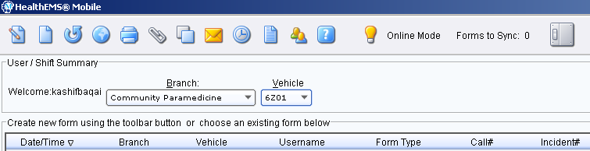

The paramedic shall then click the CAD tab on the lower half of the screen as they normally would, and open the assigned job.

The following information must be confirmed to be correct on the PCR:

Call #: **(appropriate to call)**

Branch: **Community Paramedicine**

Vehicle Unit #: **(your normal Core unit #)**

Dispatch Code: **HCCPR – Community Paramedic Response**

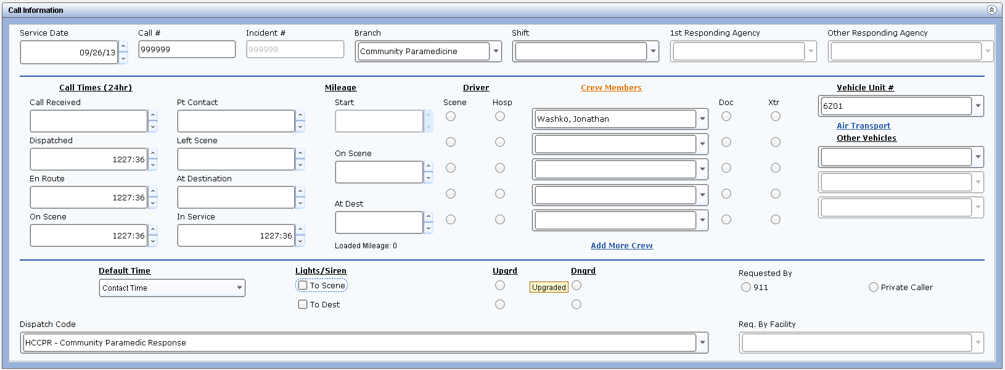

Call Disposition and Documentation:

The potential call dispositions of a community paramedicine assignment will be:

1) Evaluated, Treated & Transported

2) Evaluated & Treated

3) Evaluated & OLMC Care Plan Change

4) Evaluated only.

For all four dispositions, a Run Disposition of **“Other”** must be selected.

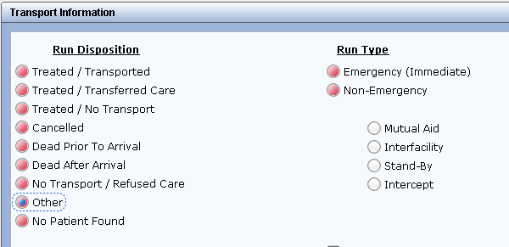

Once **“Other”** is selected it will trigger the below flex field to pop up.

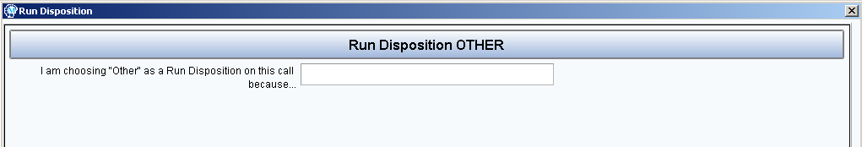

The paramedic will document **“Community Paramedicine”** in the above flex field.

**All** community paramedicine PCRs must havea series of “Community Paramedicine” treatments documented in the flow chart depending on what services were provided to the patient.

**All** community paramedicine assignments require the documentation of **“Community Paramedicine – Evaluation”** in the PCR flow chart. This is because all community paramedicine responses will at minimum require the patient to be evaluated.

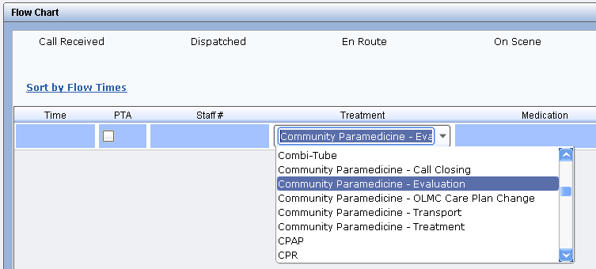

The selection of this treatment will trigger the below flex field to pop up. This flex field contains reminder prompts indicating critical information that needs to be documented in the narrative. The paramedic is to acknowledge these prompts and document accordingly in their narrative.

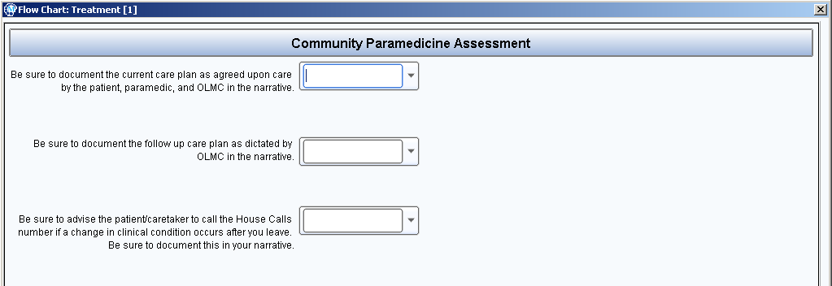

Once the crew evaluates the patient and consults with OLMC, a call disposition must be determined. The crew should have a discussion with the patient or designee and OLMC to determine the disposition that is the best course of action for the patient. Documentation of this discussion should be included in the narrative of the PCR and follow a similar format to the example below.

*[Example]*

*“After evaluating the patient and reporting the findings to OLMC, a discussion between the patient/caretaker, Dr._________, and the EMS crew was held. It was agreed by all parties that the best course of action for the patient is __________________________. The patient/caretaker understands and accepts Dr.___________’s recommendation and is aware to call the House Calls service if there is a change in the patient’s clinical condition.”*

Oncommunity paramedicine assignments where **OLMC decides to make a change in the patient’s care plan** (for example: adjusts dosage of patient’s regular medication), a treatment of **“Community Paramedicine – OLMC Care Plan Change”** must be documented in the flow chart.

This is **in addition** to the **“Community Paramedicine – Evaluation”** treatment that must documented on all community paramedicine assignments.

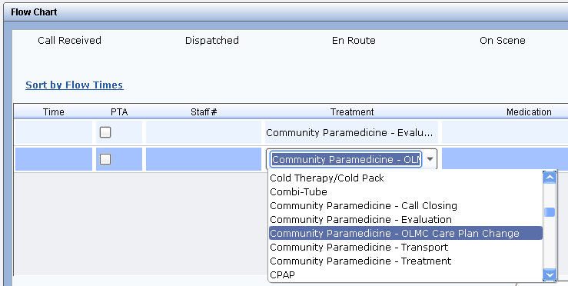

The selection of this treatment will trigger the below flex field to pop up. This flex field asks for the specific changes made to the patient’s care plan by OLMC. The paramedic is to document the changes that were made by OLMC.

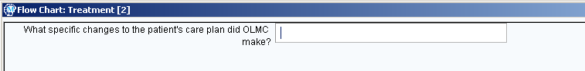

On community paramedicine assignments where the **paramedic treats** the patient **based on OLMC discretionary orders**, the treatment **“Community Paramedicine – Treatment”** must be documented.

This treatment is **not to be used** if the patient is treated under an **EMS Response** or is an **acute patient without a MOLST or DNR** that is **treated under Core Emergent protocols.**

This is **in addition** to the **“Community Paramedicine – Evaluation”** treatment that must documented on all community paramedicine assignments.

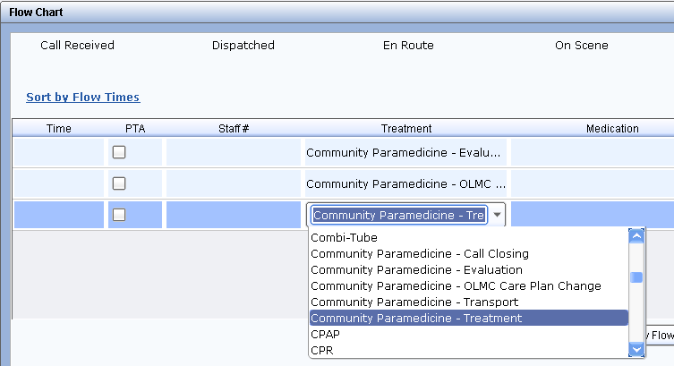

**All treatments performed (i.e. EKG, IV, O2, etc.) and medications administered must still be individually documented in the flow chart.**

On community paramedicine assignments where the patient disposition includes transport, the treatment **“Community Paramedicine – Transport”** must be documented in the flow chart.

This is in addition to all other Community Paramedicine treatment codes.

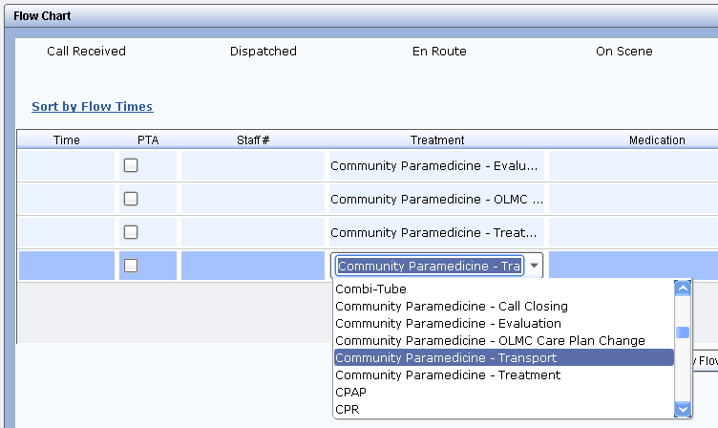

Selection of **“Community Paramedicine – Transport”** will cause the below flex field to pop up. This flex field asks for the **call number of the assignment that is generated for the transport** of the patient. The paramedic will obtain this call number when they notify C&C that the patient is going to be transported and C&C generates a new assignment for the transport.

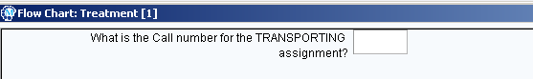

The paramedic is to document the call number in the flex field. If the Community Paramedic is the one transporting the patient, then the CP paramedic will finish and save the PCR, and copy the form as shown in the save/copy section below. If the CP paramedic is not the transporting paramedic, the CP paramedic will complete the PCR indicating in the narrative that the patient was transported and to refer to the transporting call number PCR for further information. All other patient care performed is to be documented as on a standard EMS assignment.

**All** community paramedicine assignments require the documentation of **“Community Paramedicine – Call Closing”** in the flow chart at the end of the assignment prior to leaving the patient. This is in addition to all other Community Paramedicine treatment codes as shown below.

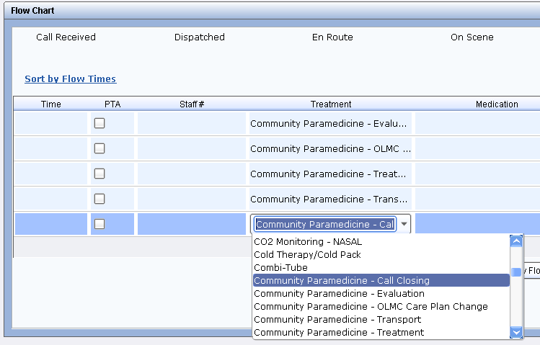

Selection of “Community Paramedicine – Call Closing” will cause the below flex field to pop up. The paramedic must answer the first three questions of the pop up for all community paramedicine assignments. For CP assignments where the patient is **not transported**, the paramedic is to click the **“Sign”** button and have the patient or designee sign the *consent for evaluation/treatment and release of liability* signature box. **(See Appendix for Release of Liability clause)**.

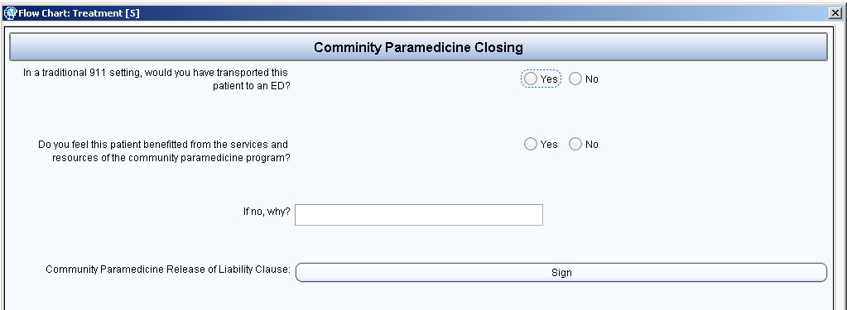

The signature field acknowledges that the patient or designee has agreed to be evaluated/treated and agreed to the recommended course of action determined by the discussion amongst the patient or designee, the Community Paramedic, and OLMC.

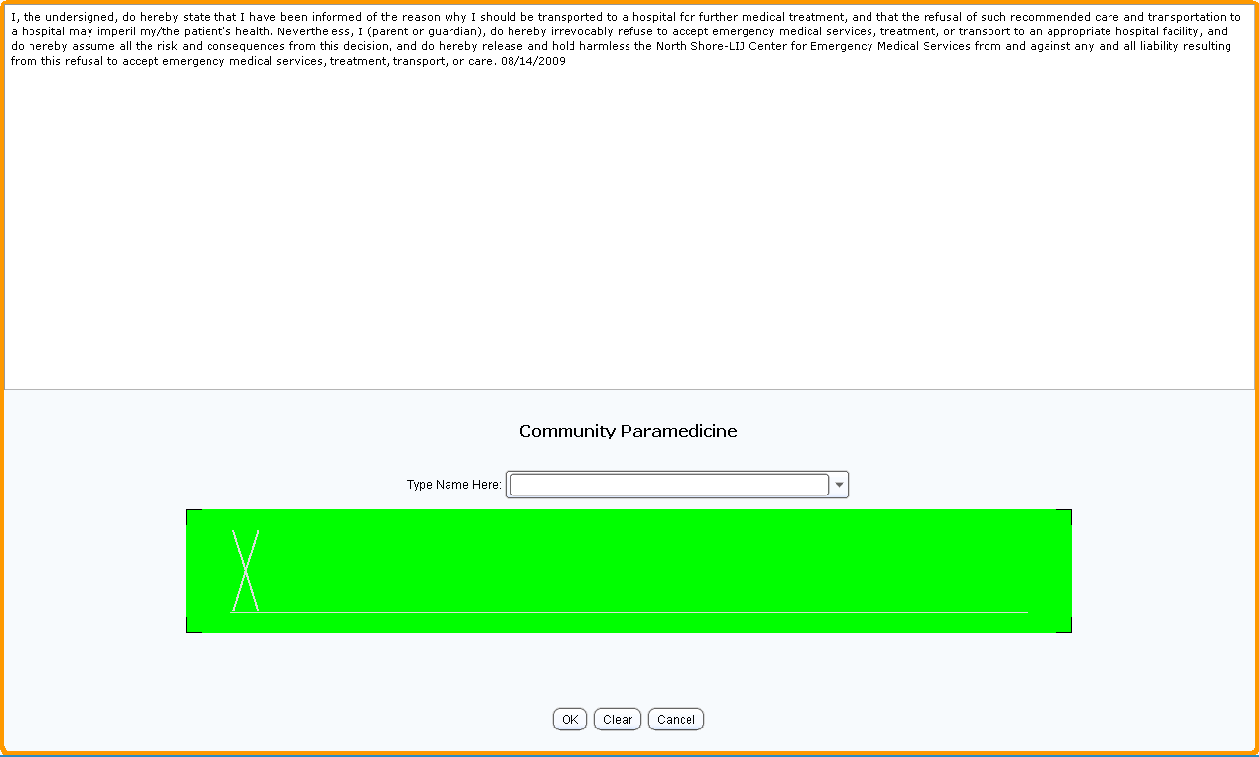

For patients who are not transported, the PCR can be closed and exported once completed. The paramedic must click the “Generate Narrative” button once the PCR is completed so all of the information from the flex field is brought into the narrative.

For patients transported by a CEMS Core unit where the CP paramedic is not the paramedic transporting the patient, the CP paramedic will fill out their PCR as above, and then add the transporting unit under “Other Vehicles.” The CP paramedic will then send the patient information to the transporting unit, using the “Share PCR” function shown below. The CP paramedic must click “Generate Narrative” **after** they have finished sharing the PCR, so that the documentation for the CP assignment is not transferred to the transporting PCR.

**Note:** the call numbers must be the same on both PCRs. The transporting unit must change the call number to the transporting call number on their PCR.

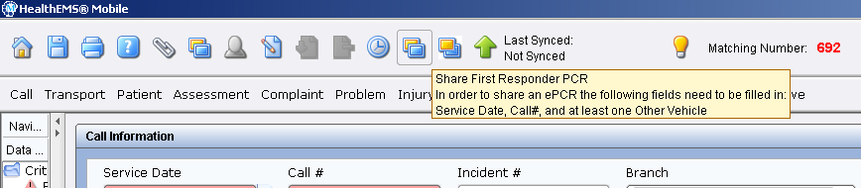

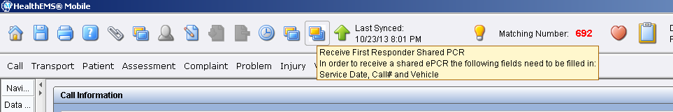

For patients who are transported by the CP paramedic, the CP PCR must first be saved by clicking the home button (on the top left) and selecting **“Save only”** from the pop-up that appears.

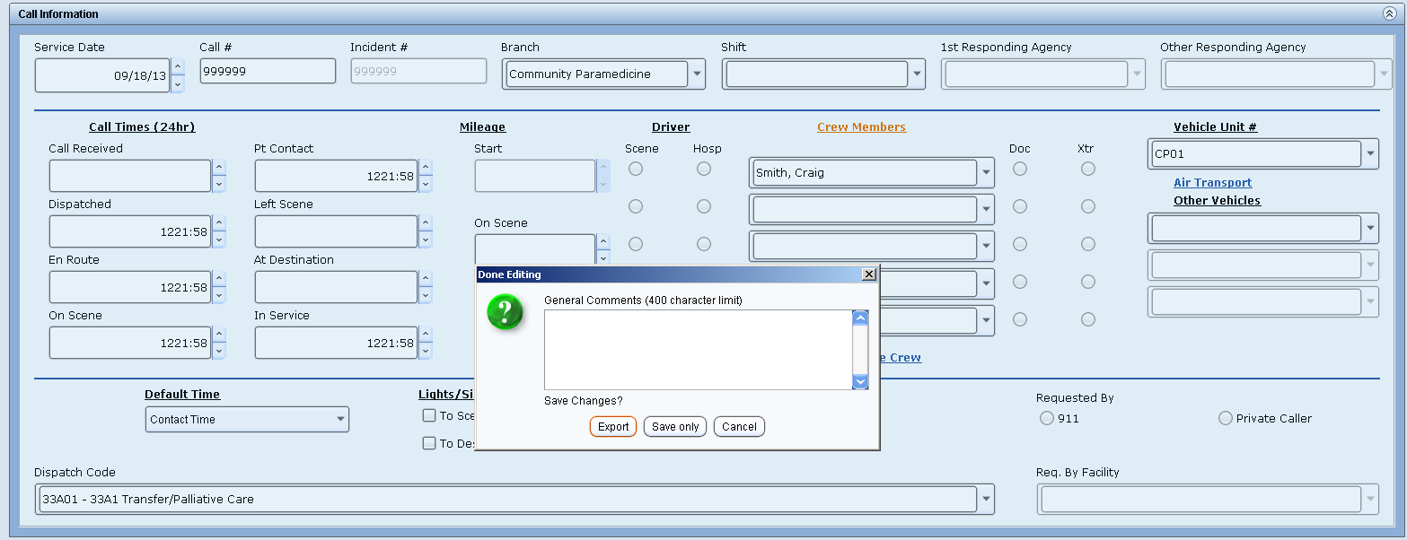

Once the PCR has been saved, the paramedic must click the **“Copy form”** button and select **“FR”** from the pop-up.

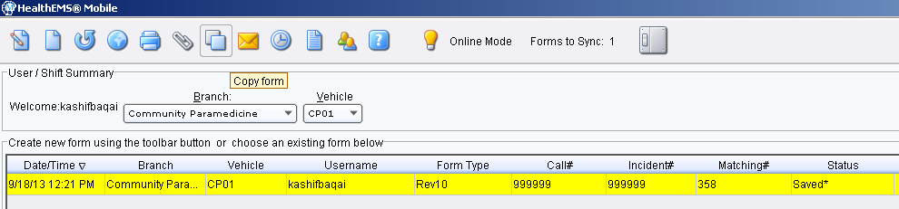

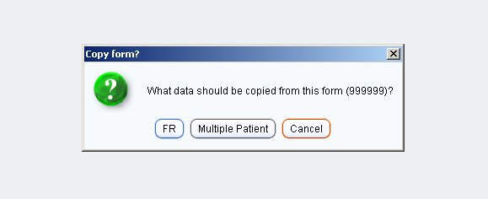

A new form will be generated carrying over all the patient information, vital signs, medications and treatments in the flow chart.

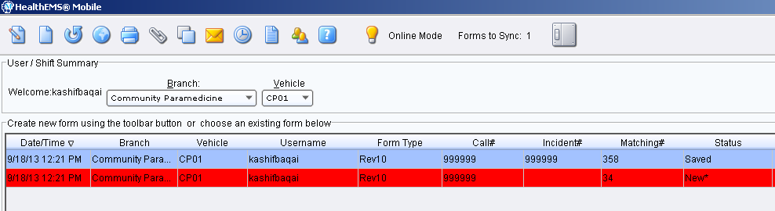

The new form should be opened and the following information needs to be updated based on the new call information received from C& C..

Call #: **(update to new call #)**

Branch: **Core (#20)**

Vehicle Unit #: **(your normal Core unit #)**

Dispatch Code: **(update to new EMD code provided by C&C)**

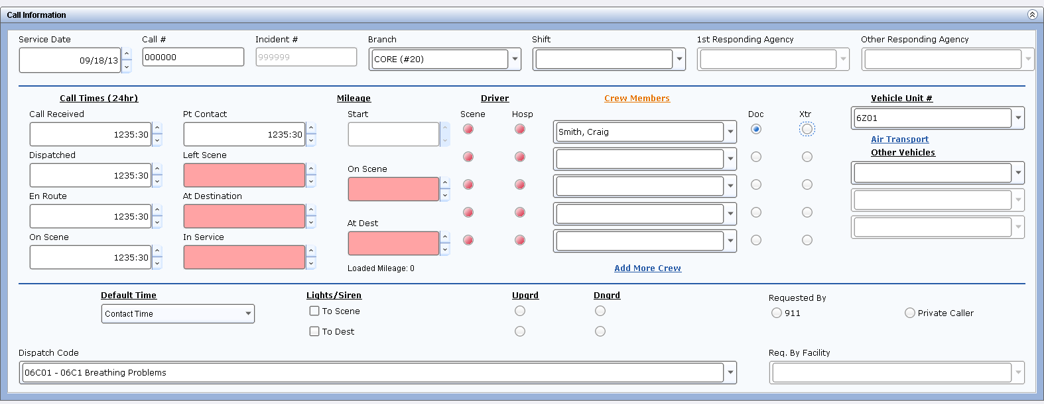

The rest of the PCR is to be completed as a normal Treated & Transported EMS assignment. Once completed with both PCRs, both are to be exported. The paramedic must return to the CP PCR and click the “Generate Narrative” button prior to exporting.

**Command & Control Guidelines:**

SOG (14.07): House Calls – Community Paramedic Response Requested

* During a House Calls Conference Call, if the MD/NP determines the patient requires further clinical assessment by a Community Paramedic or transportation for additional medical treatment
  + Click the Save button in the ECT. This will enable the ‘Emergency’ button which will convert the SCT to an Emergency Call Taking screen
  + Click the ‘Emergency’ button on the SCT
  + Run through the EMD process to determine a code (this will be used for statistical purposes, or if the patient requires transport later)
  + Change the EMD code to House Calls – Community Paramedic Response in the new ECT
  + Dispatch the closest appropriate resource to the ‘Emergency’ assignment as a cold response
* All interactions, clinical information and patient information must be documented in the Comments section of the SCT assignment
* If the patient requires transport after the Community Paramedic evaluation and treatment:
  + Create a duplicate assignment
  + Change the EMD code back to the NAEMD code determined earlier
  + Assign the EMD call to the unit on scene
    - If the unit on scene is not an ambulance, dispatch the closest ALS ambulance to the assignment

SOG (14.08): House Calls – Community Paramedic Response Dispositions

* Cancel the original House Calls (SCT) assignment using the following:

|  |  |
| --- | --- |
| **Cancellation Reason** | **Call Disposition** |
| House Call Request | House Calls – Community Paramedic Response |

* Cancel the House Calls Community Paramedic Response (ECT) assignment using the following:

|  |  |
| --- | --- |
| **Cancellation Reason** | **Call Disposition** |
| Community Paramedic | CP: Evaluated only  CP: Evaluated & OLMC Care Plan Change  CP: Evaluated & Treated  CP: Evaluated, Treated & Transported |

SOG (14.09): House Calls – Community Paramedic Follow Up Documentation

* The following documentation must be included in ALL House Calls Community Paramedic Response assignments:
* Follow Up Plan (select one):
  + No follow up needed
  + House Calls follow up - Patient Visit (Scheduled by House Calls)
  + House Calls follow up – Telephonically (Time frame for follow up is at discretion of HC MD. Scheduled CAD assignment should be built for follow up phone conference that should be initiated by CEMS C&C so that it is recorded)
  + Scheduled CP follow up (Time frame for follow up is at the discretion of the HC MD. Scheduled CAD assignment should be built to dispatch a CP unit at prescheduled time to reevaluate patient and call HC MD through CEMS C&C for follow up report)
* Call Closing Survey Questions:
  + If the Community Paramedicine Program was not available to you, would you have recommended this patient be transported to the ED for further evaluation? (Y/N)
  + If transported to the ED, do you feel the patient would have been admitted? (Y/N)

**Performance Improvement:**

PI staff will review every community paramedicine assignment within a timely manner to determine appropriateness of care delivered. Information will be evaluated to identify trends, patterns, issues, and opportunities to improve patient care. Patterns or trends will be assessed to identify the cause, and addressed with the parties involved. If a sentinel event is identified, the assignment will be discussed with Medical Directors from CEMS and the House Calls Program, who may determine the appropriate action to take with the clinician(s.) Actions to expand knowledge and improve clinical skills may include the following:

* Individual reviews and/or Continuing Education with Training & Development staff.
* Meetings with CEMS’ Medical Director or Associate Medical Director.
* Placement on a Learning Contract or Quality Improvement Plan with clearly specified guidelines and expectations.
* Review of Policies and Procedures or standards.
* Educational seminar on specific topics.
* Other counseling or re-education as deemed appropriate.

When deficiencies and/or trends are identified with individual employees, reviews with these employees will be conducted to address the deficiencies and/or trends. Subsequent steps may consist of any of the appropriate actions listed above. Records of these reviews and actions are maintained in the PI files. An assessment tool will be used to assure standardization of the reviews.

PI Community Paramedicine Assessment Tool

*Absolutes for community paramedicine and EMS responses:*

*(Y/N/Comment)*

* *Primary assessment*
* *Vital signs*
* *Mental status*
* *Provider impression*

*Conditional for community paramedicine response:*

*(Y/N/Comment)*

* *Expanded secondary assessment.*

*Length of time on scene before OLMC contact?*

*(Numerical)*

*Name of OLMC Physician?*

*(Drop down selection)*

*Was the paramedic’s initial report thorough and sufficient for OLMC to make a discretionary decision regarding treatment/transport?*

*(Y/N)*

* *No: (Free text comment box.) What additional information/assessment did OLMC request? (Obtain from telephone recordings. Trends may require amendment, clarification, or expansion of assessment tools or staff knowledge base.)*

*What diagnostic tests did OLMC request?*

*(Check box selection, multiple)*

*What treatments did OLMC request?*

*(Check box selection, multiple)*

*What medications did OLMC request?*

*(Check box selection, multiple)*

*Where any treatments requested that required transport?*

*(Y/N)*

* *Yes: (Check box selection, multiple)*

*Where any medications requested that required transport?*

*(Y/N)*

* *Yes: (Check box selection, multiple)*

*Were any treatments requested by OLMC unable to be provided due to limitations with the paramedic’s scope of practice?*

*(Y/N/Comment)*

*Call disposition:*

*(Drop down selection)*

* *Evaluated, Treated & Transported*
* *Evaluated & Treated*
* *Evaluated & OLMC Care Plan Change*
* *Evaluated only*

*Did the paramedic provide adequate documentation of follow up requested by OLMC?*

*(Y/N/NA).*

* *House Calls clinician home visit*
* *Community paramedicine home visit*
* *CCC telephone call*
* *Alternative actions*

*Length of on-scene time (Numerical)*

*Free text comment box for any additional PI review findings.*

**Analytics:**

The analytics for this program will consist of the following metrics:

Statistics for medications and treatments that are used on CP assignments

Query HealthEMS on a monthly basis to determine the frequency of all medications being administered and treatments being performed.

Statistics for the number of transports to the ED that were avoided

Query HealthEMS on a monthly basis for the results of the flex field which is completed after each CP response; the flex field requires the paramedic to determine if, in their judgment, a transport to an ED was avoided by the use of a community paramedic response.

.

Statistics for the number of readmissions to the hospital that were avoided

Query results on a monthly basis from survey given to OLMC clinician after each CP response to determine if, in their judgment, a readmission was avoided by the use of a community paramedic response.

Statistics for patient/customer satisfaction

Analyze results from satisfaction surveys distributed by department.

Operational statistics

Response times

Time on scene

Call disposition

Number of CP revisits within a specified time period

Number of CP responses where a CP unit was not available as a primary unit

**Physician Oversight:**

Physician Oversight will be a shared process with both the medical specialists from House Calls and EMS collaborating. Although oversight should include all aspects of patient care, the following are the core components of the oversight plan.

CEMS Clinical Quality Assurance:

PCR/OLMC contact review: 100% of all community paramedicine assignments will be assessed for the below criteria. Immediate feedback will be provided to the staff for improvement.

Phone calls and PCRs should be assessed for:

1. Adequate patient assessment by the paramedic.
2. Appropriate documentation by the paramedic.
3. Appropriate communication between the paramedic and OLMC.
4. Appropriate care for the given patient condition by the paramedic.
5. Adherence to operating guidelines of the program by the paramedic.

Medical Control Quality Assurance:

Clinician Credentialing: Credentialing of clinicians will be in accordance with CEMS Policies and Procedures, and Nassau County REMSCO Policies. Review and feedback will be provided to medical control providers based on the following criteria:

1. Adherence to the guidelines and policies of the community paramedicine program by the medical control clinician.
2. Are clear, concise instructions, within the paramedic’s scope of practice, being given by the medical control clinician?
3. Are the medical control clinicians and paramedics agreeing on patient care plans or are many cases reverting over to EMS responses? Are cases being referred to CEMS Administration?

Operational Quality Assurance:

Physician oversight of operational quality will consist of tracking/review of the following Command & Control data and review/approval of Command & Control / Clinical Call Center policies and procedures.

Operational data to be tracked and reviewed will be:

1. Cost avoidance effectiveness (number of transports/readmissions avoided.)

2. Numbers of patient contacts.

3. Numbers of patient transports.

4. Number of patient contacts per community response credentialed paramedic.

5. Number of patient contacts per OLMC clinician.

6. Number of each case type or Chief Complaint/Provider Impression.

7. Ages and genders of patients.

8. Number of CP assignments with advanced directives in place.

9. Number of assignments with up to date medical reconciliation forms available (either with OLMC or with the patient.)

10. Number of assignments with up to date medical histories available (either with OLMC or with the patient.)

Patient satisfaction surveys should be conducted on a regular basis to gauge overall satisfaction with community paramedic services. Improvements will be made as necessary.

Training and Education Guidelines:

House Calls Clinicians:

* CME/Updates
* Encourage physician time in the call center
* Encourage physician time on a CP ambulance

Community Response Credentialed Paramedics:

* CME/Updates.
* Encourage CP paramedic to attend House Calls grand rounds
* Encourage CP paramedic to participate in rotations in ED/Medical Offices to practice physical exam skills and patient assessment techniques.

As the CP program begins, open lines of communication between all providers, both House Calls clinicians and CP paramedics, should be established and maintained.

**Community Paramedicine Flow Charts:**







**Appendix:**

Primary Assessment

1) Form a general impression

2) Assess level of consciousness:

* AVPU
* Orientation (person/place/time/event)
* GCS
* Pupils

3) Assess the airway: Identify and treat life threats

* Obstructions (Complete/Partial)

4) Assess breathing status: Identify and treat life threats

* Respiratory rate
* Rhythm (regular/irregular)
* Quality/Character of breathing
* Depth of breathing

5) Assess the circulation: Identify and treat life threats

* Pulses (rate/quality/rhythm)
* Skin (color/temperature/moisture/capillary refill)
* Assess and control external bleeding

6) Perform rapid scan

7) Determine priority of patient care and transport

Expanded Secondary Assessment:

Vital signs (SBP & DBP / pulse / respiratory rate / SpO2 / pain)

Expanded Physical Exam

Temperature

Weight

Nasal EtCO2

3 & 12 – Lead EKGs

Skin condition

Wound assessment

Invasive tube insertion site assessment

In-home medical equipment assessment

Medication reconciliation/review

Environmental/living conditions

Caretaker capability

Community Paramedicine Diagnostic Capabilities:

• Community Paramedic Assessment/Expanded Physical Exam

• Pulse oximetry

• 3-Lead EKG

• 12-Lead EKG

• EtCO2 Monitoring (Nasal/Advanced Airway)

• Blood glucose level

• Temperature

• Weight

Community Paramedicine Treatment Capabilities:

• BLS airway management (OPA/NPA)

• Suctioning (Hard-Yankauer/Soft Suction catheter)

• Oxygen therapy (blow by/nasal cannula/nebulizer/trach mask)

• BVM ventilation

* Adjustment of patient’s in-home medical equipment

• Burn care

* Hemorrhage control

• Chest tube insertion site assessment

• Central line insertion site assessment

• Cold pack therapy

• Direct laryngoscopy

* IV catheter/saline lock placement
* IV catheter/saline lock removal
* Nasogastric tube insertion site assessment
* Pain management
* Medication administration
* Intramuscular
* Intravenous
* Subcutaneous
* Oral
* Sublingual
* Intranasal
* Rectal
* Nebulized

Community Paramedicine Formulary:

• Magnesium Sulfate – 4 x 1 gram (1g/2mL)

• Solu-medrol – 1 x 125mg (125mg/2mL)

• Glucagon – 1 x 1mg (1mg/mL)

• Nitroglycerin – 1 bottle (25 count / 0.4mg)

• Metoprolol – 3 x 5mg (1mg/mL)

• Labetalol - 1 x 100mg (5mg/mL)

• Ondansetron – 2 x 4mg (2mg/mL)

• Dextrose 50% - 2 x 25 grams (0.5g./mL)

• Albuterol (0.083%) – 4 units (2.5mg/3mL)

• Tetracaine (0.5%) – 1 x 2ml vial

• Naloxone – 1 x 4mg (0.4mg/mL)

• Aspirin – 4 x 81mg tabs

• Furosemide – 1 x 100mg (10mg/mL)

• Ipratropium Bromide – 4 units (0.5mg/2.5mL)

• Sodium Chloride 0.9% - 4 x 1L, 4 x 250mL, 3 x 100ml, 3 x 50ml

• Diazepam – 4 x 10mg (5mg/mL)

• Fentanyl – 2 x 100mcg (50mcg/mL)

• Diphenhydramine – 1 x 50mg (50mg/mL)

• Midazolam – 2 x 10mg (5mg/mL)

• Morphine Sulfate – 2 x 10mg (10mg/mL)

• Lorazepam* (subject to availability)

Chronic Medical Condition Management Capabilities:

• Diuresis (CHF)

• Fluid challenge (hypovolemia/diabetes)

• Pain management

• Nebulizer treatment administration (COPD/asthma)

• Hypoglycemia management (diabetes)

• Opiate overdose management

• Antiemetic administration

• Seizure management

Treatments requiring transport for further evaluation:

• ALS airway management (ETT/ King LT airway placement)

• BiPAP/CPAP

• Severe hemorrhage control (bandaging/occlusive dressing/ tourniquet)

• C-Spine/Spinal immobilization

• Defibrillation / Cardioversion

• External pacing

• IO placement (except in the event of a pronouncement)

• Long bone splinting

Medication administrations requiring transport for further evaluation:

• Atropine – 3 x 1mg (0.1mg/mL)

• Dopamine – 1 x 400mg (80mg/mL)

• Adenocard – 5 x 6mg (3mg/mL)

• Epinephrine (1:10000) – 7 x 1 mg (0.1mg/mL)

• Calcium Chloride (10%) – 2 x 1 gram (100mg/mL)

• Vasopressin – 2 x 20 units (20units/mL)

• Amiodarone – 3 x 150mg (50mg/mL)

• Diltiazem – 1 x 100mg (1mg/mL)

• Epinephrine (1:1000) – 3 x 1mg (1mg/mL)

• Sodium Bicarbonate – 2 x 50 mEq (1 mEq/mL)

• Etomidate – 2 x 20mg (2mg/mL)

• Vecuronium – 2 x 10mg (1mg/mL)

Community Paramedicine Release of Liability Clause:

*I have been evaluated, and treated (if appropriate) by a North Shore-LIJ Center for Emergency Medical Services (EMS) paramedic. The paramedic reported my current health condition to a clinician who is credentialed to provide medical direction to the paramedic. I have made my healthcare goals known to the paramedic including my wish to remain at my current location. I understand that this evaluation is limited and that if I want to be fully evaluated, I need to be transported to an emergency department, hospital or other healthcare facility. I understand the risks and benefits of all options currently available, up to and including transport to an emergency department, hospital, or other healthcare facility. At the present time, I am choosing to remain at my residence/current location and not be transported. I agree that I or my designee will contact my health care provider or will call EMS if at any time my health condition needs further evaluation or if my condition worsens.*

*Although I do not want to be transported, I agree to evaluation and treatment by the paramedic, as well as the medical advice of the clinician. I assume all the risks and consequences from this decision, and hereby release and hold harmless the North Shore-LIJ Health System, its trustees, employees, affiliates and staff including the paramedic and clinician and the North Shore-LIJ Center for Emergency Medical Services from and against any and all liability resulting from evaluation and treatment and the decision to remain at my residence/current location and not be transported to an emergency department, hospital, or other healthcare facility.*

Health Care Reform Background Information:

The Patient Protection and Affordable Care Act

The Patient Protection and Affordable Care Act was signed into law on March 23, 2010. The bill enacts reforms to provide affordable health insurance to 44 million uninsured Americans and to reduce the growth in healthcare spending.

The Patient Protection and Affordable Care Act is focused on healthcare funding, reducing the cost of healthcare for Americans, increasing coverage and removing the burden that healthcare has become in the years since it has become a law. It aims to reform the American healthcare system in favor of the people, away from the monopoly of the healthcare insurance industry.

The Impact

Medicare and Medicaid will be impacted as payments shift from fee for service to capitation.

*Fee for Service*

Fee for service payments are made based on invoices for services delivered. In this system, neither the healthcare provider nor the patient has any incentive to control medical cost. The risk of cost overruns caused by this issue is assumed by the payer (insurance company / government / patient) and not the provider. This, combined with more people consuming healthcare than paying into the funding, creates financial difficulties for healthcare institutions providing the services.

### *Capitation Payment*

A purpose of capitation payment is cost control by aligning the incentive for all parties to benefit the patient in the most economically efficient manner.

Under a capitation system, healthcare service providers (physicians) are paid a set amount for each enrolled person assigned to that physician or group of physicians per period of time, regardless of whether that person seeks care.

The amount of remuneration is based on the average expected healthcare utilization of that patient (additional remuneration for patients with medical history). Other factors considered include age, race, sex, type of employment, and geographical location.

The capitation system provides certainty to both providers (doctors, hospitals) and payers (insurance companies) as to the financial aspects of care delivery. The incentives are for the providers to care for the patient thoroughly and efficiently, as any relapses in care cost the provider time and resources. As there is no additional compensation for diagnostic tests or treatments that must be performed due to previous oversights or errors, providers would greatly benefit by caring for the patient the right way, the first time.

Fee for Service versus Capitation Payment – A Comparison

|  |  |  |
| --- | --- | --- |
|  | Fee for Service | Capitation |
| Risk assumed by: | Payers (insurance companies) | Healthcare providers (doctors, hospitals) |
| Method of payment: | No fixed payments. Providers bill for services delivered and are paid predetermined rates for each service. | Fixed payment per year, determined by size of population enrolled to receive care and a per-member fee. |
| Financial Incentives | Keeping a patient admitted to a hospital as long as possible to maximize billable services. | Keeping a patient healthy and out of a hospital. |

Beginning in 2014, the healthcare overhaul will dictate that Medicare no longer reimburse healthcare providers if a patient is readmitted to a hospital within 30 days of discharge with a preventable repeat of the previous diagnosis. This change will be a driving force for rethinking medical intervention within homes and communities, and create sharp new incentives for follow-up home care. There will be a proactive aim to keep patients out of hospitals, while ensuring safety and quality of medical care.

The original thread of community paramedicine traces back to rural areas of eastern Canada. Nova Scotia experimented with the concept around 2000, when a doctor who had served two remote islands off the Canadian coast retired; paramedics were recruited to offer care of these underserved populations. This experiment led to the practice of employing preventative medicine to serve homeless populations in cities such as San Francisco and San Diego, in an effort to reduce the number of requests for 911 service, and the ambulance response costs associated with those requests.

Key Drivers

Medicine is best practiced locally, and every community faces its own unique set of challenges. Gaps in healthcare allow opportunity to pay particular attention to those needs and problem areas. The North Shore-LIJ Health System aims to provide a community paramedicine service, integrate principles of public health, and employ preventative medicine strategies.

Health System Integration

The Center for EMS (CEMS) is an integral part of the North Shore-LIJ Health System. Its integration removes many barriers that other EMS systems encounter. With the support and resources of the health system, CEMS will be able to promptly implement a community paramedicine program and deliver the intended services and necessary care.

Community Paramedics (CP) will be vital members of the healthcare continuum, and they will fill a crucial role by helping to assess and evaluate community-specific needs, as well as fill the gaps between the needs of the community and the services of healthcare systems. The CP will navigate and establish systems to better serve communities and clients. They will help individuals and communities overcome barriers, which currently prevent them from accessing and benefiting from health services. They will serve as advocates, facilitators, liaisons, and resources coordinators. CPs will be trained as direct service providers, with an advanced knowledge base and level of skill appropriate for disease prevention and management, evaluation and assessment, triage, and treatment of patient conditions of varying levels of acuity. The CP will help to ensure the overall goal of mentoring and empowering clients, and will bring concerns forward to achieve positive outcomes and reach the optimal level of wellness for members of the community.

There exists a large community of patients with chronic or terminal illness who require medical attention. Many of these have limited or no mobility, making their need to seek medical attention a challenge. These patients may avoid seeking care in an effort to avoid the challenges of transportation, thus forcing their condition to remain untreated. Those who do seek care are subject to the stress of transportation and the change in both environment and support system, followed by time spent in an emergency department. While an ED’s resources and ability to immediately manage acute patients are clearly of tremendous value, it is not the appropriate resource for these chronically ill patients. ED care is provided by a clinician unfamiliar with their medical history, and very often, the result is an unnecessary admission to a hospital. The chronically ill patient suffers, and the valuable resources of the ED are unnecessarily taxed.

NS-LIJ House Calls and CEMS are proposing a response to these groups of chronically ill patients. This response is an opportunity to position appropriately trained mobile healthcare providers into a community that has previously relied upon on emergency room to assist in managing chronic ailments. The CP will not replace existing healthcare services, but will fill the gaps that currently exist.

Training the Community Paramedic

The CP will receive advanced training, initially standardized to address a variety of chronic diseases, geriatric care, thorough and comprehensive patient assessment, and utilization of various diagnostics. The training curriculum will match to meet the current needs of House Call program through a standardized multi-module delivery model.

After program implementation and analysis of trends from call responses, CP training and education will be modified or expanded to align with the needs of patients and healthcare providers alike. The services provided by the CP be driven by established operating guidelines and decisions made by designated physicians. These physicians will utilize the CP as a physician extender, to serve as their eyes, hears, and hands, allowing the patients to benefit from quality healthcare at the right time, place, and cost.

Clinical Experience Goals

The clinical experience goals are for North Shore LIJ Health System Advanced Trained Paramedics to gain hands on experience examining the geriatric patient in the emergent and non-emergent clinical setting. Advanced trained paramedics will use assessment skills and criteria set forth by the National EMS Education Standards and the North Shore LIJ Health System Center for EMS.

Clinical Experience Objectives

* Become proficient using advanced techniques of inspection, palpation, percussion, and auscultation
* Locating and assessing pulses in a geriatric patient.
* Distinguish among methods of assessing breathing in the geriatric patient.
* Differentiate a patient with adequate and inadequate minute ventilation.
* Assessing mental status and differentiate assessing altered mental status in the geriatric patient
* Assess vital signs including temperature
* Predict patterns of injury based on the mechanism of injury.
* Forming a general impression of the patient.
* Discuss & perform methods of assessing the airway in the geriatric patient.
* Describe normal and abnormal findings when assessing skin color, temperature, and condition.
* Evaluation of a patient’s perfusion status based on findings in the primary survey.
* Identify patients who require expeditious transport.
* Differentiate the assessment performed for a patient who is unresponsive or has an altered mental status and other medical patients requiring assessment.
* Apply the techniques of physical examination to the medical patient.
* Apply the techniques of physical examination to the trauma patient.
* Differentiate patients requiring a detailed physical examination from those who do not.
* Differentiate normal and abnormal findings of the assessment of the skin, hair, and nails.
* Distinguish the importance of abnormal findings of the assessment of the skin including skin ulcerations and decubiti.
* Describe the examination of the head and neck.
* Differentiate normal and abnormal findings of the scalp examination and perform.
* Perform the normal and abnormal assessment findings of the skull.
* Perform the assessment of visual acuity.
* Perform the examination of the eyes.
* Distinguish between normal and abnormal assessment findings of the eyes.
* Describe the examination of the ears.
* Differentiate normal and abnormal assessment findings of the ears.
* Describe the examination of the nose.
* Differentiate normal and abnormal assessment findings of the nose.
* Perform the examination of the mouth and pharynx.
* Perform the examination of the neck.
* Differentiate normal and abnormal assessment findings of the neck.
* Perform the assessment of jugular venous pressure and pulsations.
* Differentiate normal and abnormal assessment findings of the chest examination.
* Perform the examination of the anterior and posterior chest including voice sounds (fremmitus).
* Differentiate the characteristics of breath sounds.
* Differentiate normal and abnormal assessment findings of the heart and blood vessels.
* Differentiate the characteristics of normal and abnormal findings associated with auscultation of the heart.
* Perform examination techniques of the cardiovascular examination (heart sounds).
* Differentiate normal and abnormal assessment findings of the abdomen.
* Perform percussion, palpation &auscultation of the abdomen.
* Distinguish normal and abnormal findings of the auscultation of the abdomen.
* Perform Genitourinary exam limited to the evaluation of a foley catheter and urine production
* Differentiate normal and abnormal findings of the musculoskeletal system.
* Differentiate normal and abnormal findings of the nervous system.
* Perform detailed neurological exam
* Describe the general guidelines of recording examination information.

Advanced problem-focused Physical Exam Techniques and Skills

for the Advanced Pre Hospital Care Provider

for the home bound (geriatric) patient. Caps?

Essence of examining each body system includes: Observation/inspection, palpation, percussion, auscultation. Examining each body part often requires different techniques to maximize the exam. For example, some techniques are best done with the patient sitting, standing or even laying flat (as best as tolerated).

Refer to copies of pages 17-23 of Bates by Bickley. We will review the techniques of advanced physical exam and diagnosis during this lesson. The diseases reviewed will be the most common, high yield/high frequency/emergent types.

(This presentation was compiled with multiple reference sources, but follows the format and derives bodies of text from the textbook Bates’ Guide to Physical Examination and history taking, 10th Edition.)

1. First Impressions/General state of health
   1. Introduce yourself: When they shake your hand, is their hand; strong, weak, shaking, arthritic, pale? Are the nails blue, atrophic, pale? Is there muscle wasting? Did they give you the wrong hand (Is this normal behavior? “Dead fish” handshake?) (TIP: start your neuro/psych exam here.)
   2. Level of consciousness-(use your A.V.P.U. pneumonic)
   3. Posture, motor activity, gait (did they answer the door for you?), dress, grooming, hygiene, any odors of body or breath-yes this matters.
   4. Watch facial expressions noting manner, affect and reactions to people and things in the environment
   5. Listen to the patient’s speech
   6. Look at how they look at you. Some psychiatric illness present here at the door (depressed patients may not make eye contact, or just look at their hands or feet). Are their eyes conjugate or dysconjugate (E.O.M)
   7. Obtain weight while standing-why have patient who is standing, sit down for exam, then get back up for weight? Always consider this.
2. Obtain Vitals, weight, pulse ox, ETCO2 (if relevant via nasal sampling), glucose, and temp, discussion to review current knowledge and new parameters.
3. Skin
   1. Observe for dryness and temp
   2. Note any lesions-location, distribution, type and color.
   3. Look at hair and nails
   4. Look at hands
   5. Look for rashes, ulcers, suspicious lesions, even suspicious bruises.
4. HEENT
   1. Hair, scalp skull and face
   2. Does hair appear to be falling out, or is there pruritis (lice?)
   3. Eyes: acuity, position of eyes and eyelids, inspect sclera and conjunctiva, compare pupils (test reaction to light), assess extraoccular movements.
   4. Ears: Hearing
   5. Nose and mouth: look at mucosa, look for nasal flaring, cyanosis, etc. Assess teeth, gums tongue tonsils and pharynx.
5. Neck:
   1. Inspect for trach/scars
   2. Sub-q air, crepitance or tracheal deviation
   3. Listen for stridor
   4. Look and feel for masses and note location (midline, para-tracheal, etc)
6. Back:
   1. Inspect and palpate spine and muscles, look for asymmetry (eg, winged scapula)
   2. Look for kyphosis,
   3. Look at skin for rashes, bruises (zoster, falls with bruises, abuse? bug bites, ulcers?)
7. Thorax and Lungs:
   1. Assess breath sounds in multiple locations with multiple techniques (see lung assessment module)
8. Cardiovascular:
   1. Observe for JVD
   2. Listen to heart sounds
9. Abdomen:
   1. Inspect, auscultate, percuss and palpate
10. GU: Foley catheter assessment-(see Foley catheter assessment module)
11. Extremities:
    1. You have already looked at the hands and should have looked at the upper extremities, now look at lower extremities. Look for symmetry, edema, vascular changes.
    2. Check pulses
12. Nervous System:
    1. Mental status
    2. Cranial nerves
    3. Motor and sensory
    4. Psychiatric