Combat Ready Clamp (CRoC) Skill Sheet

Objective: Demonstrate the proper application of a Combat Ready Clamp using both the direct and proximal pressure methods.
References:
TCCC Curriculum, CRoC Module
Evaluation: Students will be evaluated as a Pass/Fail (P/F). The instructor will verify the student’s ability to quickly and effectively apply a Combat Ready Clamp to a fellow student by observing the student’s procedure and technique.
Materials:
Student Checklists
Combat Ready Clamps
Students perform on each other
Instructor Guidelines:
- Provide each instructor with Student Checklists.
- Ensure each student has all required materials.
- Read the Learning Objective and the evaluation method to the student.
- Explain the grading of the exercise.
The Combat Ready Clamp (CRoC)) (Figure 1) is a junctional pressure device for use in tactical situations where traditional methods of dressing and pressure do not work to control bleeding in the inguinal region.

Figure1. CRoC
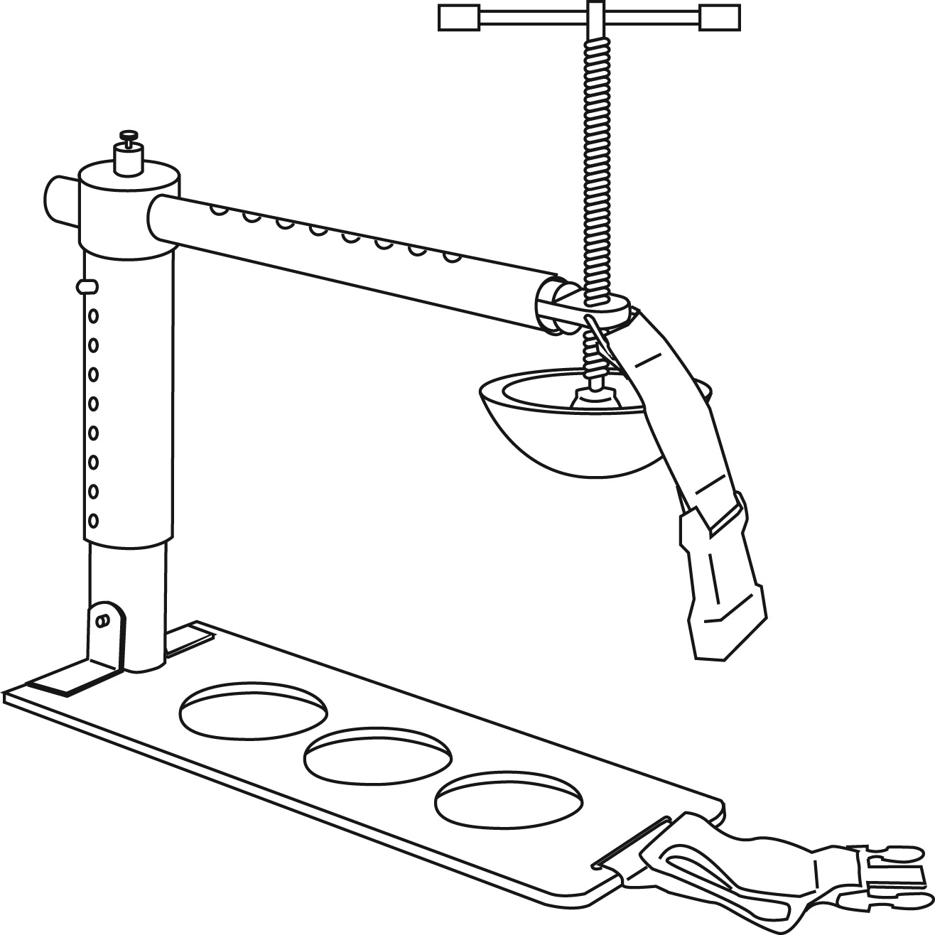

A trained provider can apply a CRoC quickly and easily. The CRoC is supplied disassembled in a compact case for minimum volume.

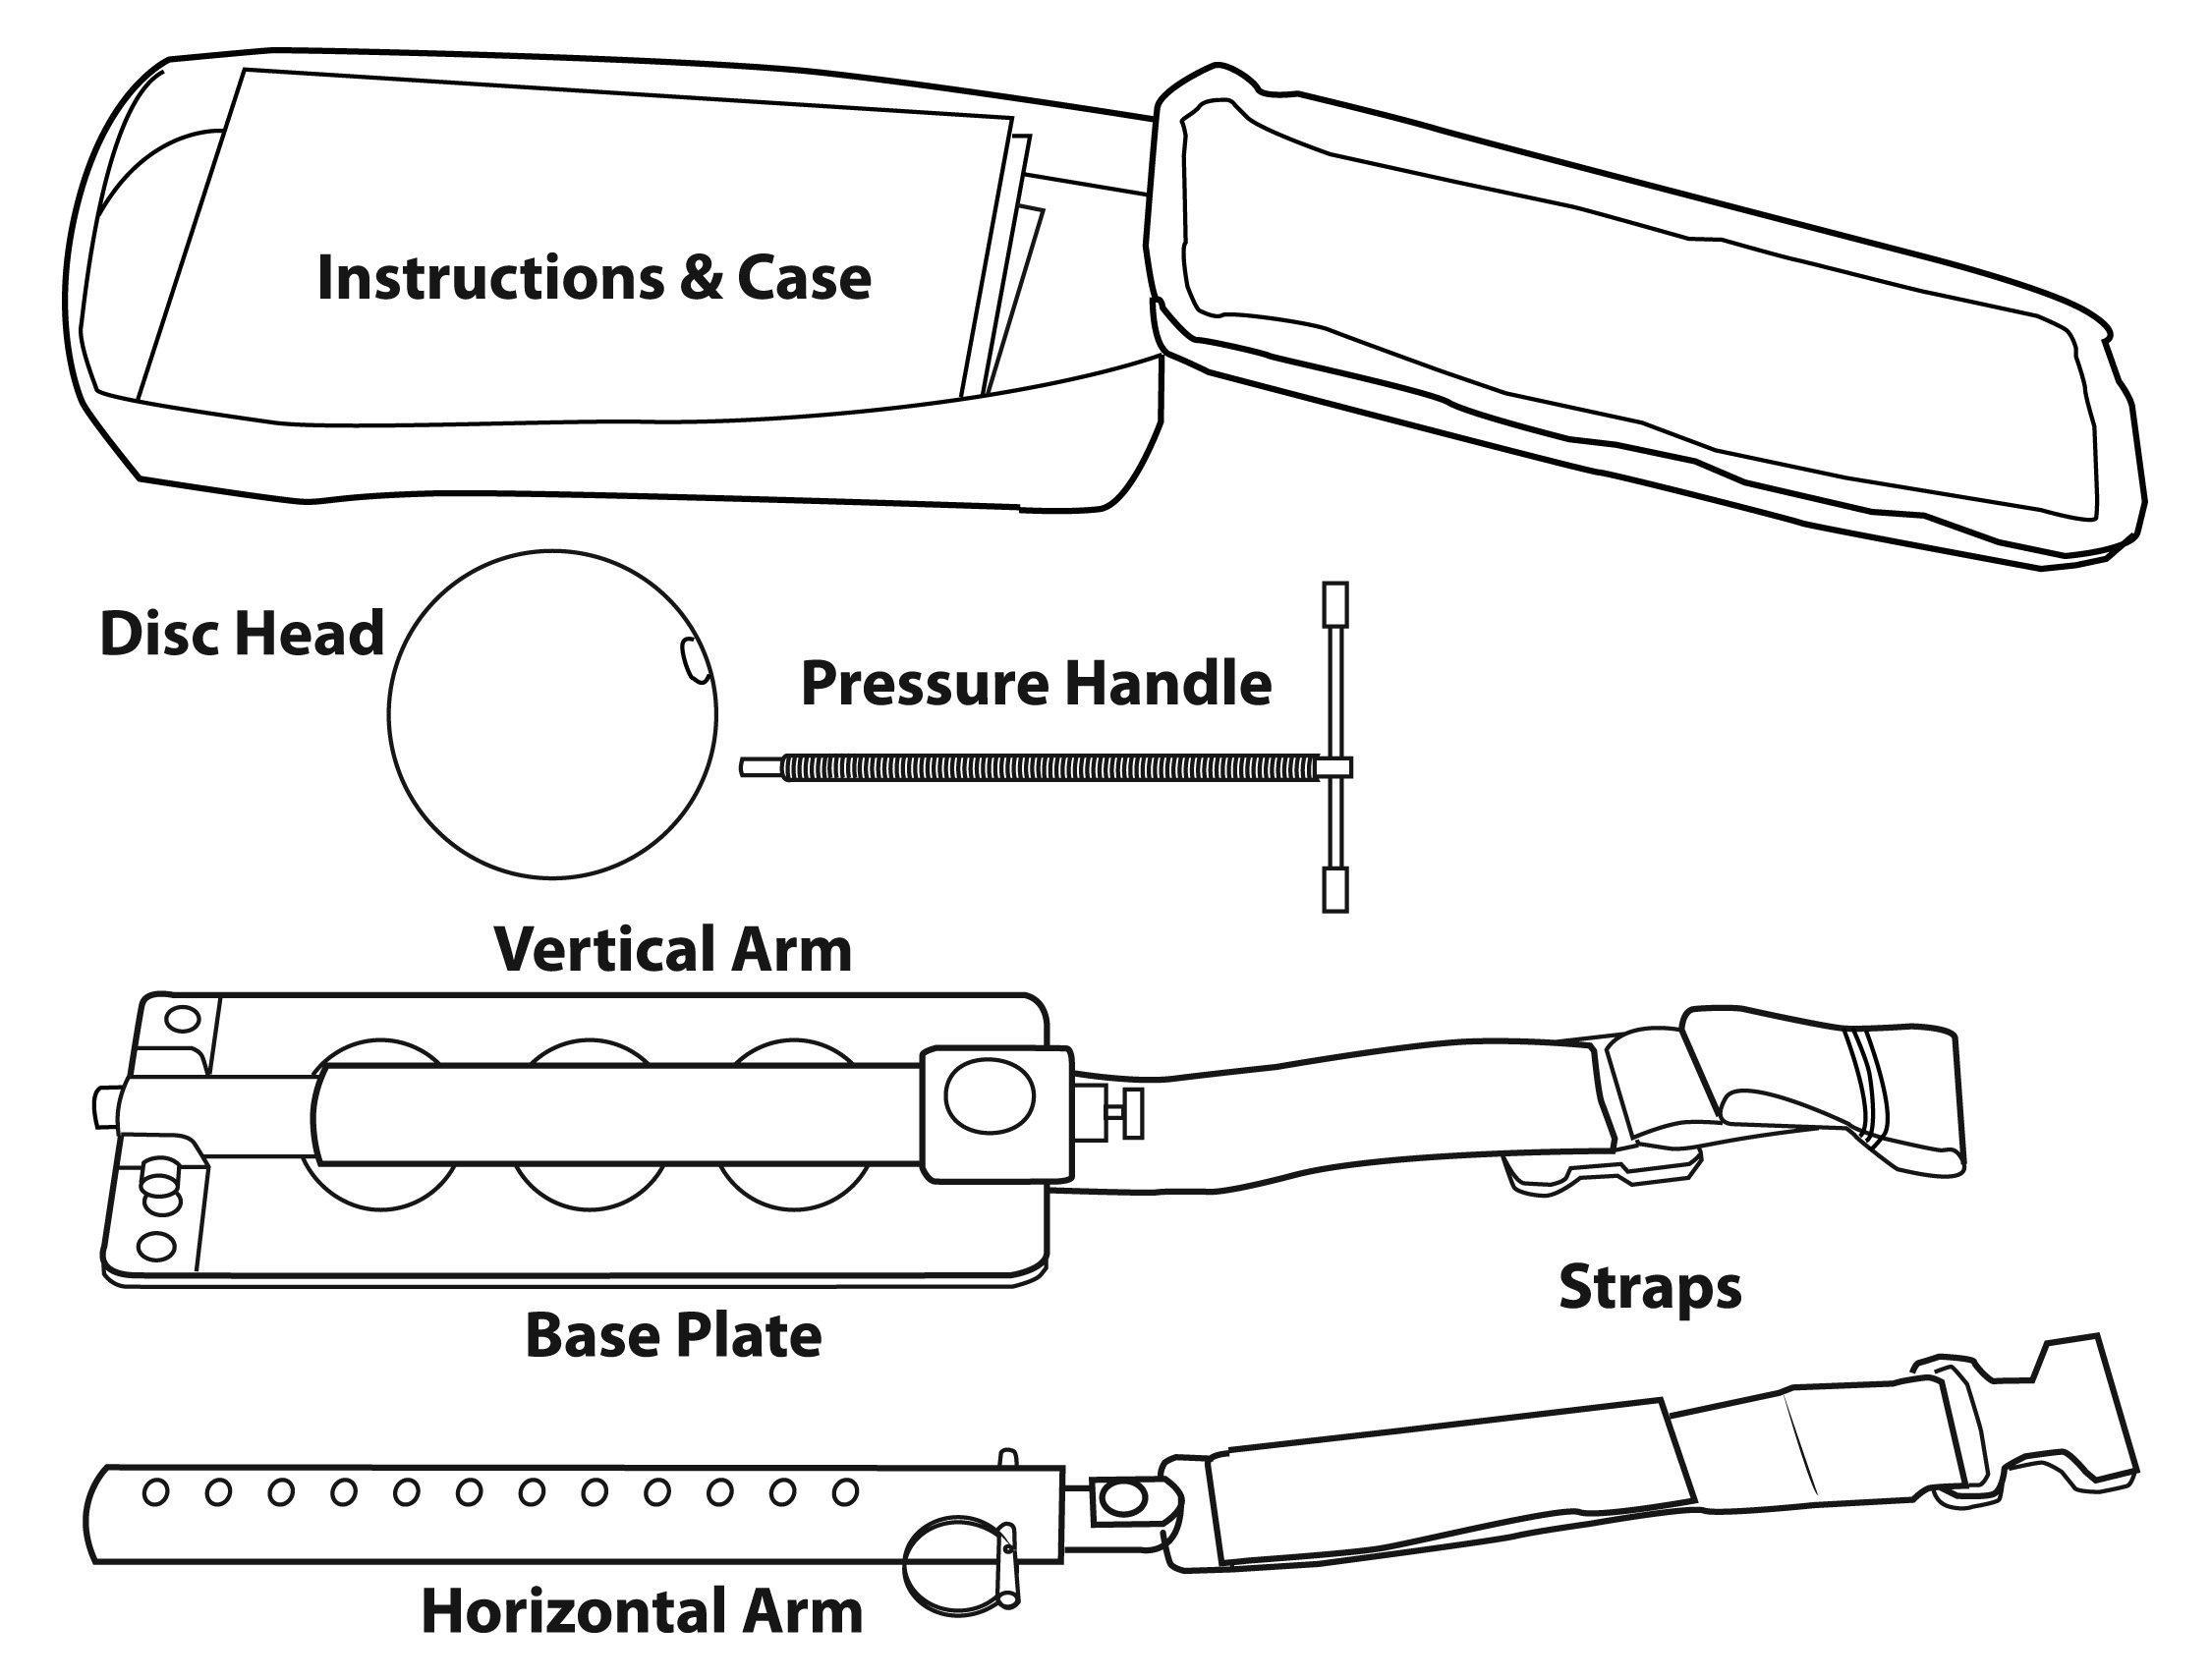

Applying the CRoC
1. Remove CRoC from its case.
2. Assemble CRoC (as shown in Figure 3)
a. Extend vertical arm up from base plate.
b. Lift the horizontal arm locking pin and insert horizontal arm
c. Insert pressure handle rod into horizontal arm head and rotate clockwise until pressure disc attachment tip is clear.
d. Attach the pressure disc to pressure handle rod
e. Depress the vertical arm locking pin and adjust the vertical arm to desired position (Note this will be depend on casualty size).

Figure 3. Assembly

a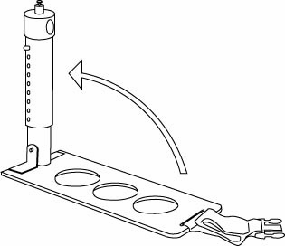 | b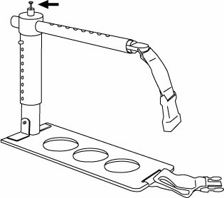

c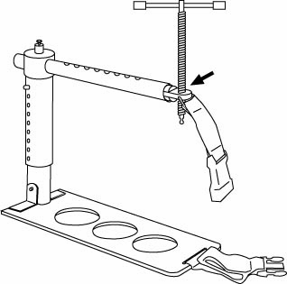 | d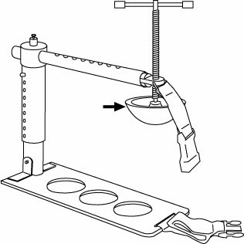

e.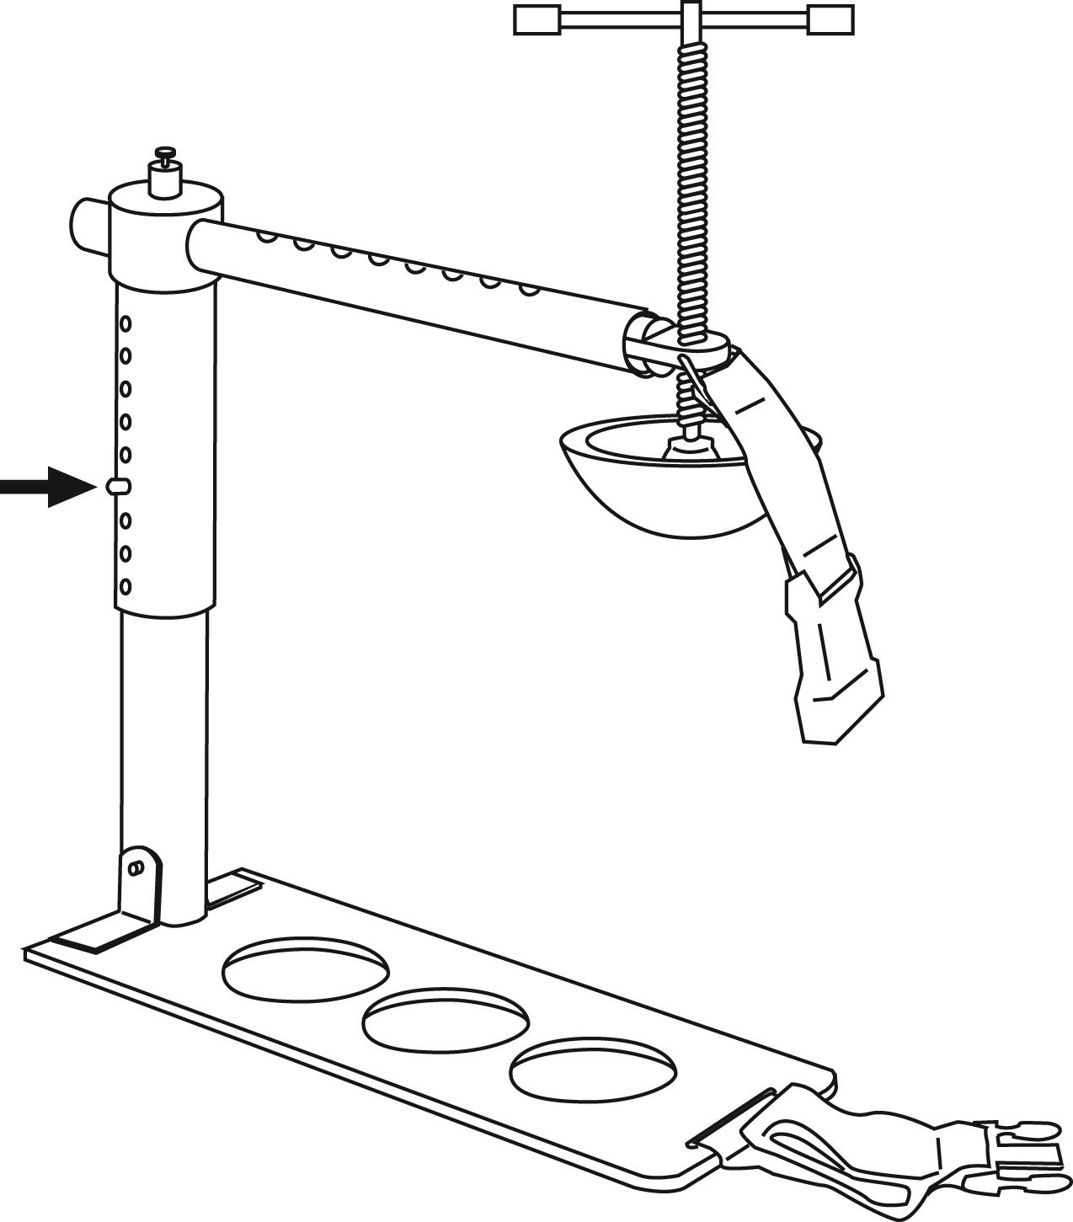

3. Applying the CRoC with the Direct Pressure Method (Figure 4)
This method is used to control hemorrhage from a wound in the inguinal area that is not being controlled by traditional methods. The CRoC applies pressure directly over wound.

- Position the base plate under the casualty beneath the desired pressure point.
Ensure the vertical arm is in contact with the casualty on wounded side in close proximity to wound location.

b. Adjust the horizontal arm to position the pressure disc above the dressing on the wound. (The horizontal arm is adjusted by lifting the horizontal arm locking lever and sliding the arm to desired position and reengaging the pin.)

c. Adjust the vertical arm downward to ensure the pressure disc is in contact with the dressing. (The vertical arm is adjusted by depressing the vertical locking pin and adjusting the arm downward and reengaging the pin.)

d. Apply pressure to the dressing by rotating the pressure handle clockwise. Stop when the pressure disc is in firm contact with the mock casualty’s skin. (Student will verbalize that on a real casualty, pressure would be applied until the bleeding stops.)

e. Apply pressure until the bleeding stops.

f. Attach the securing strap.

g. Write the time of application on the CRoC’s label and the TCCC Card.

Figure 4. Application – Direct Pressure Method

a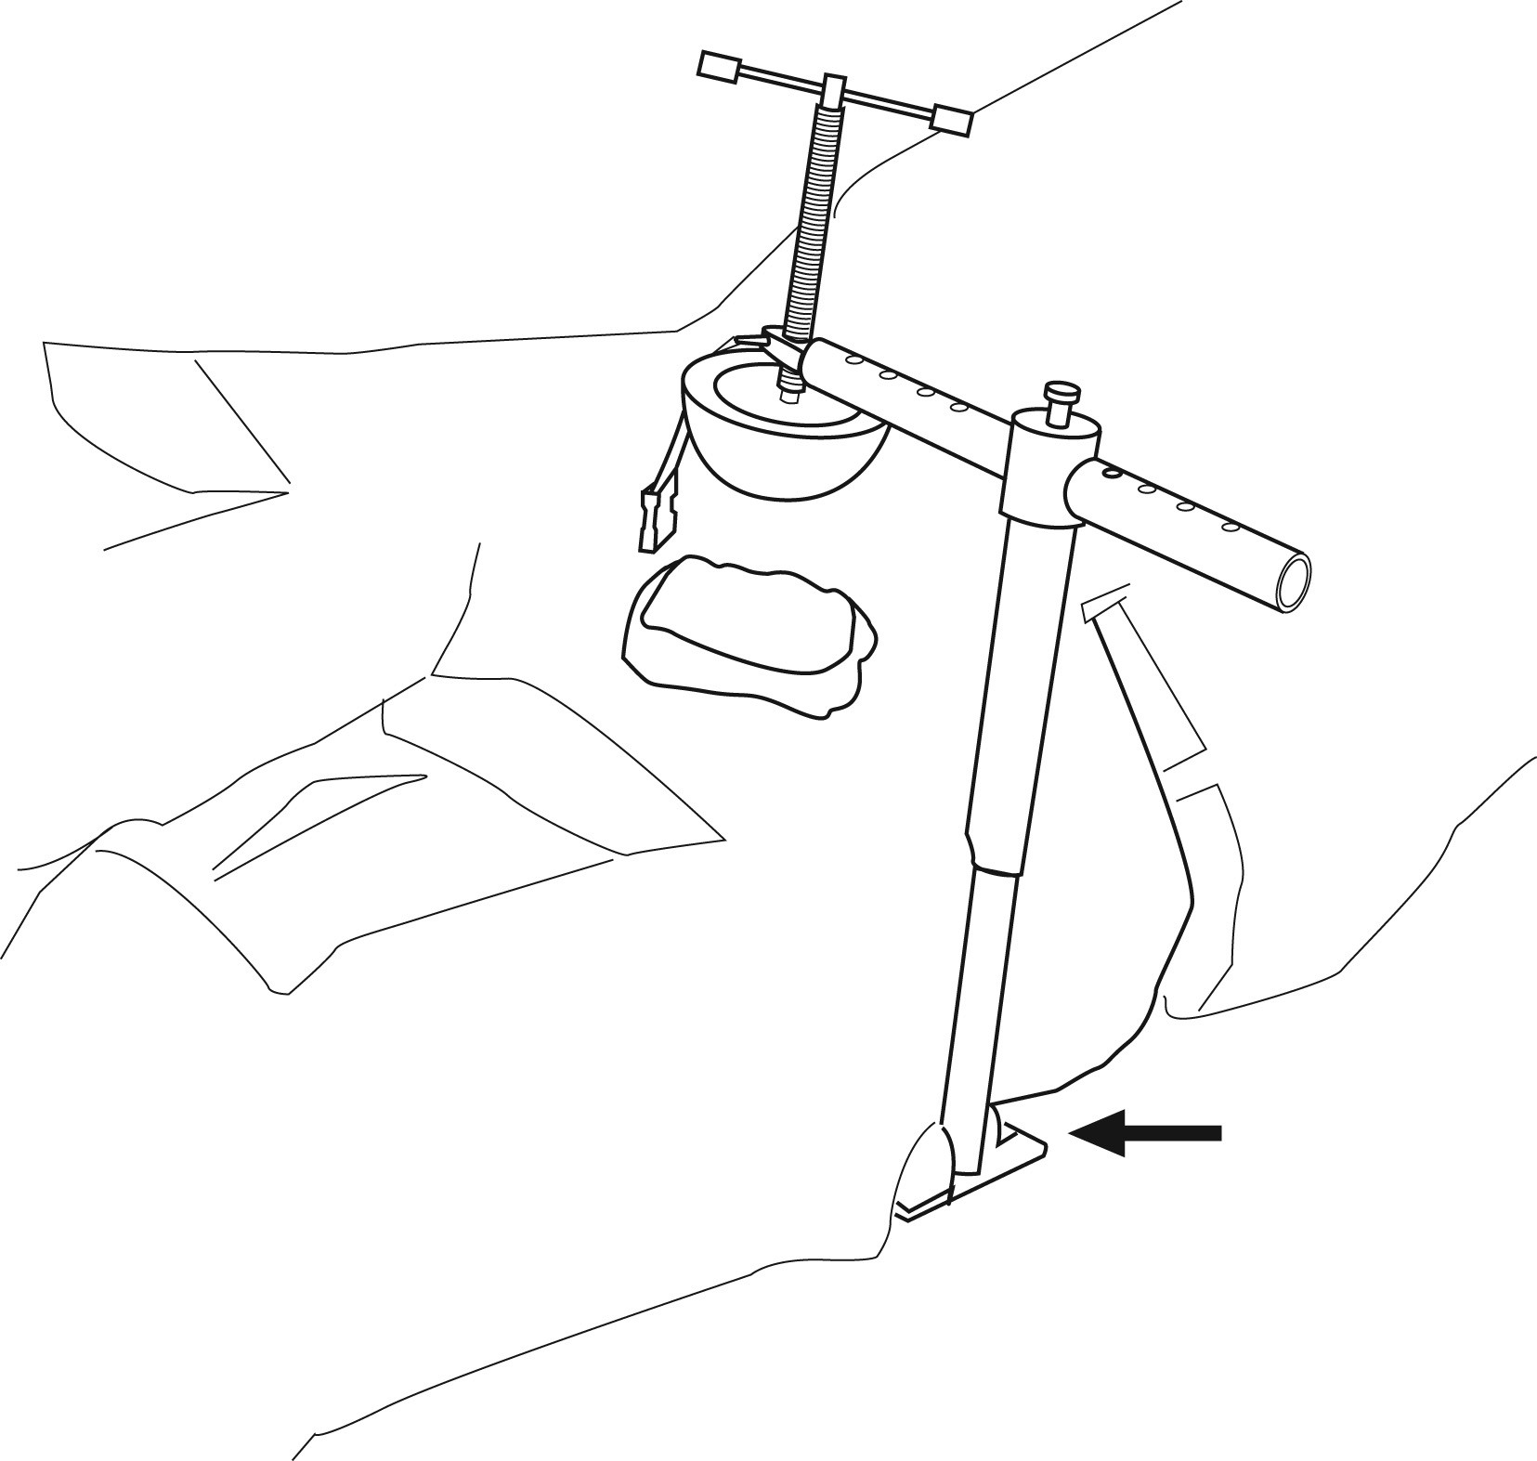 | b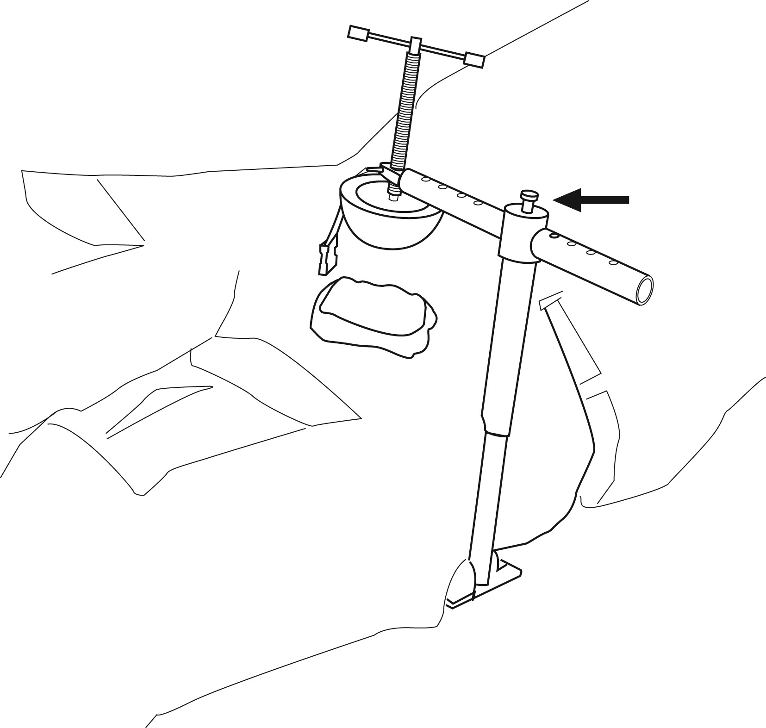
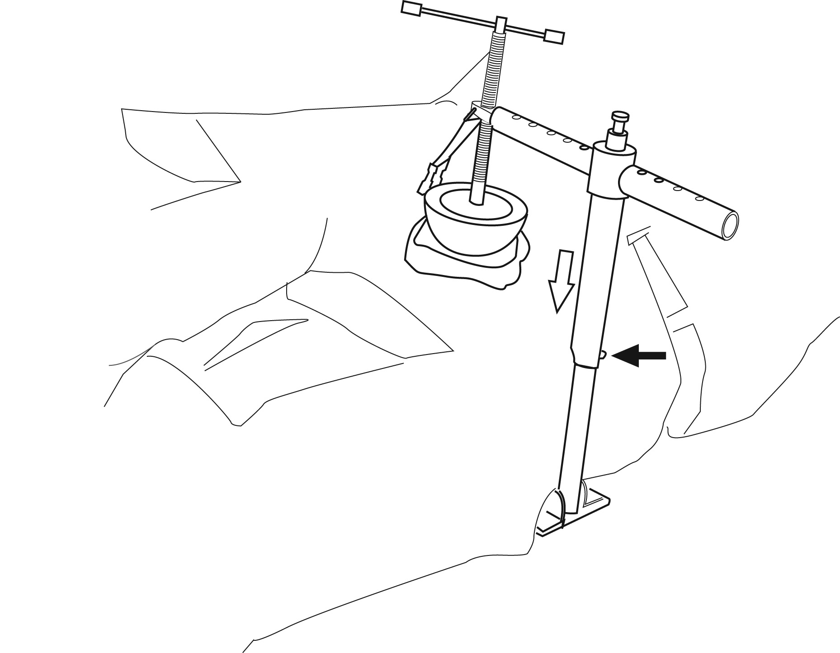  c | 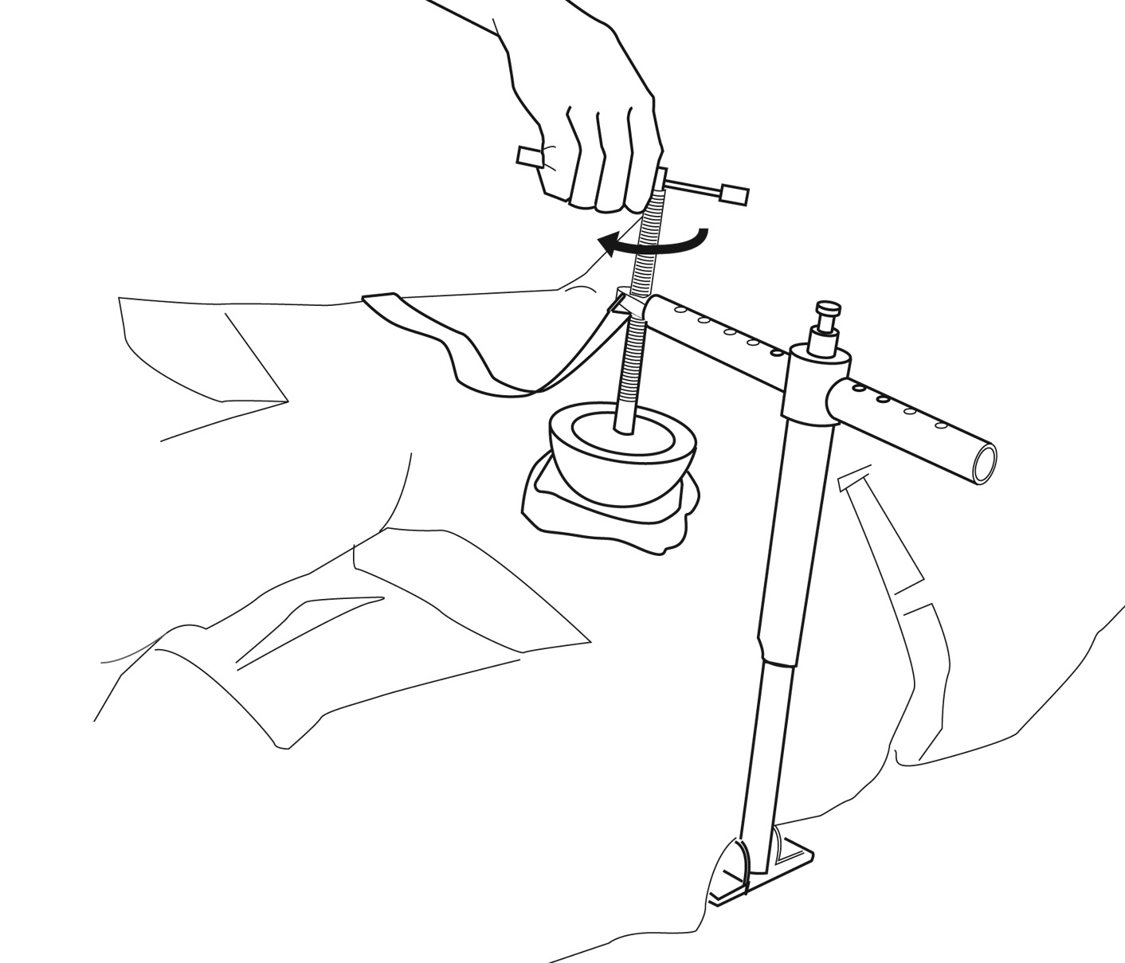  d

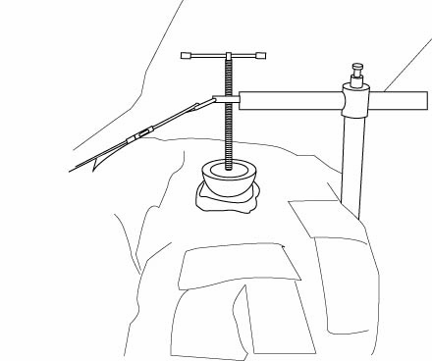
e

4. Application – Proximal Pressure Method

a. Position the base plate under the casualty beneath the desired pressure point at the inguinal ligament. Ensure the vertical arm is in contact with the casualty on wounded side in close proximity to wound location.

b. Adjust the horizontal arm to position the pressure disc above the desired pressure point (Figure 5).

c. Adjust the vertical arm downward to ensure the pressure disc is in contact with the skin at the desired pressure point.

d. Apply pressure by rotating the pressure handle clockwise. Stop when the pressure disc is in firm contact with the mock casualty’s skin. (Student will verbalize that on a real casualty, pressure would be applied until the femoral pulse just distal to the pressure disc is no longer palpable, and the bleeding stops.)

e. Attach the securing strap.

f. Write the time of application on the CRoC’s label and the TCCC Card.

Figure 5 – Finding the Desired Pressure Point, Proximal Pressure Method

- Locate the pubic tubercle.
- Locate the anterior superior iliac spine (ASIS).
- Between these points is the inguinal fold. Find the mid-point of the line halfway between these two landmarks.
- Locate the femoral pulse and place the pressure disc directly over it, just medial and distal to this midpoint (not on the inguinal ligament).

5. Positioning a Casualty on a Litter with the CRoC Applied

Care should be taken when moving the casualty in a tactical environment. The CRoC should be reassessed after each casualty movement.

a. Roll the casualty onto the unaffected side.
b. Position the litter beside the casualty.
c. Roll casualty onto litter.
d. Casualty can be transported on the unaffected side or place padding below casualty to elevate the affected side slightly as shown in Figure 6.
Note: The CRoC could shift during transport if this step is not performed.
e. Reassess the casualty.

Figure 6
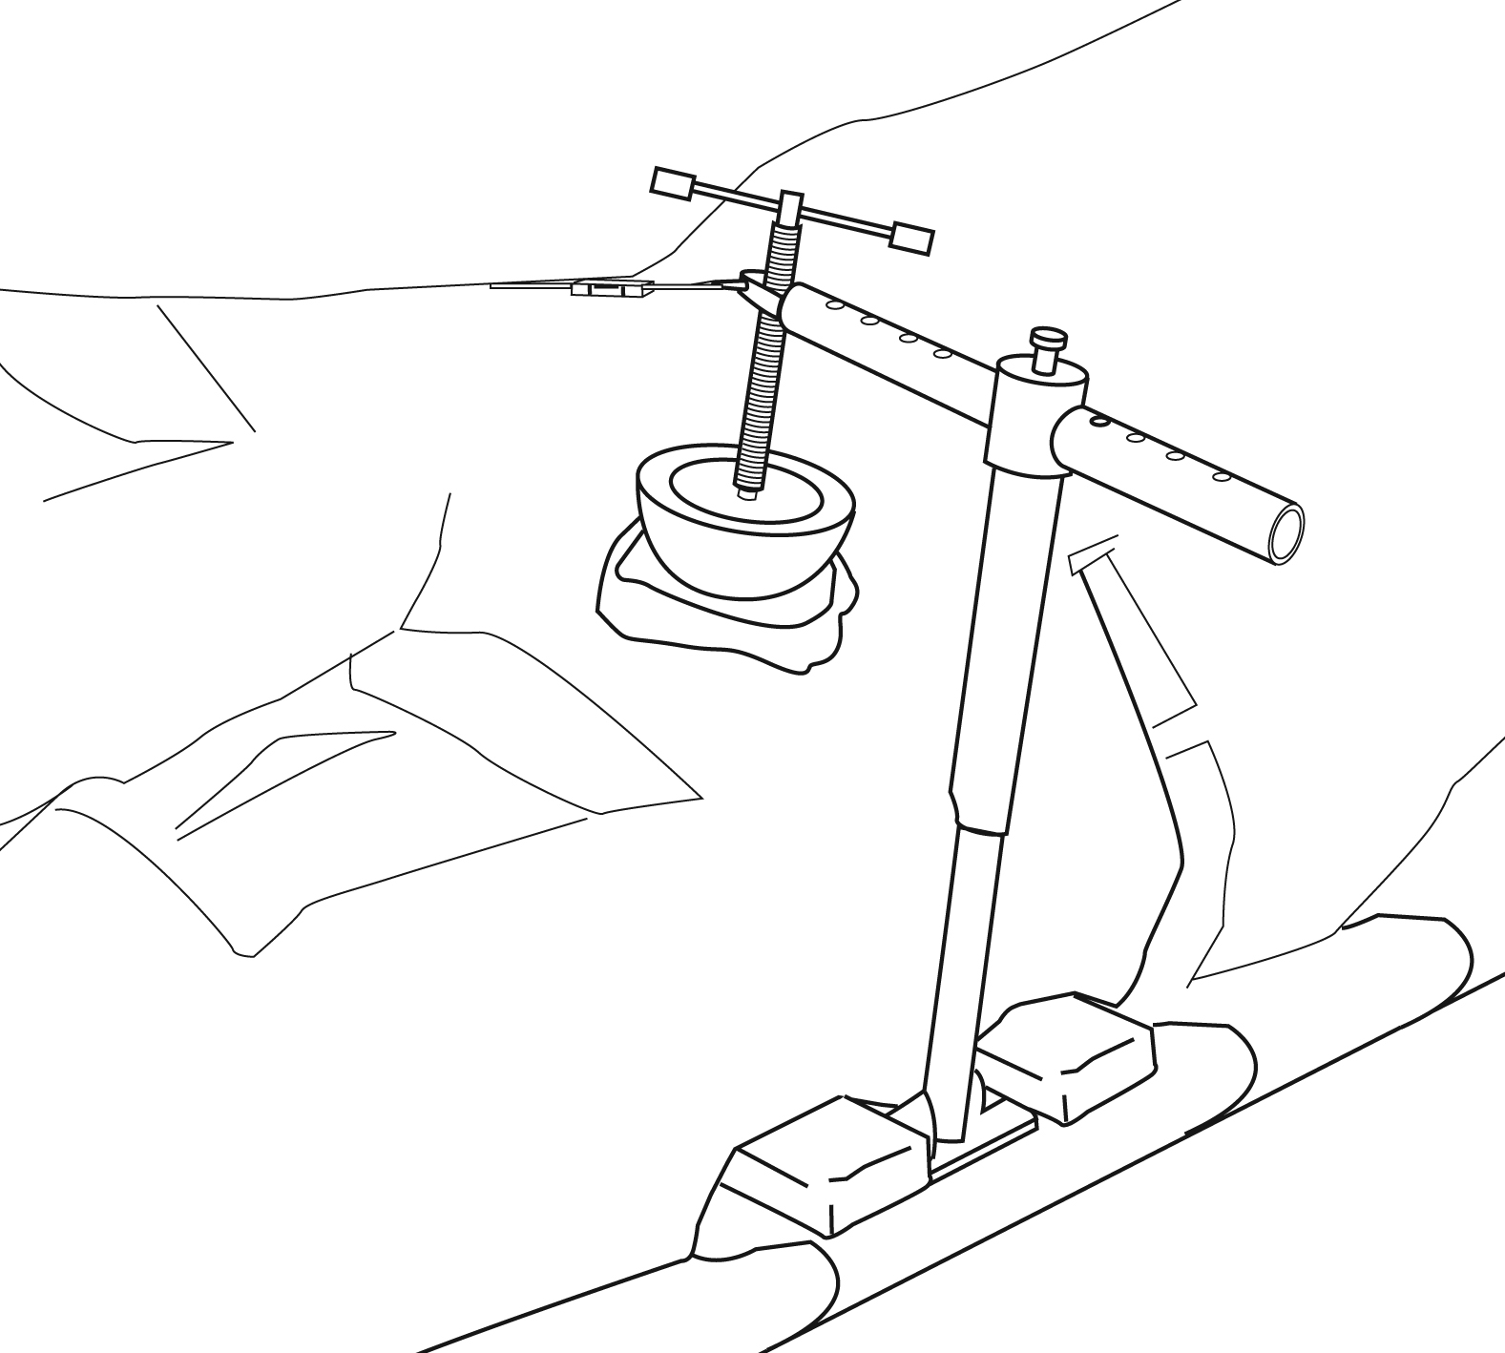

Student Checklist
Control Bleeding Using a Combat Application Tourniquet

Task | Completed
 | 1st | 2nd | 3rd
Removed the CRoC from its case and assembled it correctly. | P / F | P / F | P / F
For the direct pressure method, applied the CRoC directly over the wound dressing. | P / F | P / F | P / F
For the proximal method, applied the CRoC directly over the femoral pulse at the inguinal ligament. | P / F | P / F | P / F
For the direct pressure method, applied pressure by turning the pressure handle clockwise until the disc head was in firm contact with the wound dressing. | P / F | P / F | P / F
For the proximal method, applied pressure by turning the pressure handle clockwise until the femoral pulse just distal to the pressure disc disappeared. | P / F | P / F | P / F
Attached the securing strap. | P / F | P / F | P / F
Verbalized recording the time of application on the CRoC’s label and the TCCC Card. | P / F | P / F | P / F
Correctly moved the casualty with the CRoC applied onto a litter. | P / F | P / F | P / F
Correctly positioned the casualty on the litter and/or correctly inserted padding to protect the CRoC during transport. | P / F | P / F | P / F

Critical Criteria:

_____ Did not correctly position the CRoC for the method used.

_____ Did not verbalize appling sufficient pressure.

_____ Did not secure the CRoC properly for litter movement.

Evaluator's Comment

Student Name: |  |  | Date:
Evaluator: |  | Pass: |  |  |  | Fail:

